112年學力檢測測驗題本
英語文七年級
作答注意事項：
各位同學：
你們好。
這是一份英語文的試題，總共35題。
第一個部分是15題聽力能力檢測，
第二個部分是20題閱讀能力檢測。
測驗時間為45分鐘。
每一題請選一個最合適的答案，並用2B鉛筆在答案卡畫記，不可超出格線外，如果需要修改答案，請用橡皮擦擦拭乾淨，再重新畫記。
畫記說明：
當你想選擇的答案為時，正確畫記為 ●
其他事項：
- 每一題都要回答。
- 試題如有錯誤，請立即告知老師。

學 校
班 級
座 號
姓 名
112年學力檢測測驗題本
英語文七年級聽力及閱讀測驗

各位同學，我們將要進行英語的聽力測驗和閱讀能力測驗。第一部分是聽力測驗共三大題，每一題都會先說明作答方式，請注意試題本上的例題，錄音說明完才會開始播放考試的題目。

每題會播放兩遍，題目不在試題本上，請依照聽到的內容，並看到各題的四個選項中，選出一個正確或最佳的答案，並畫記在答案卡上。錄音唸下一題時，你就要跟著做下一題。錄音會帶著你做完所有的聽力題目。開始作答後，請自行完成測驗，監考老師不會回答任何問題。但是你如果感覺身體不舒服，可以舉手向監考老師反應。

現在請翻頁。聽力測驗即將開始，請安靜並專心作答。

第一部分：聽力能力檢測，共三大題，15小題。
第一大題：辨識句意（第1-5題）
作答說明：請依據所聽到的句子，選出符合描述的選項，每題播放兩次。

示例題：你會看到
 | 
 | 

然後你會聽到．．．．．（播音）。依據所播放的內容，正確答案應該選，請將答案卡該題「」的地方塗黑、塗滿：即 ●

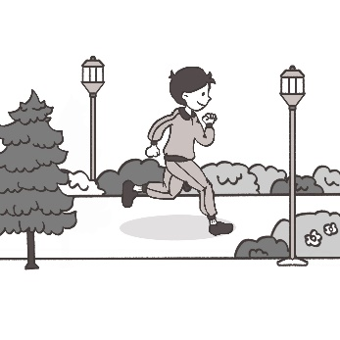 | 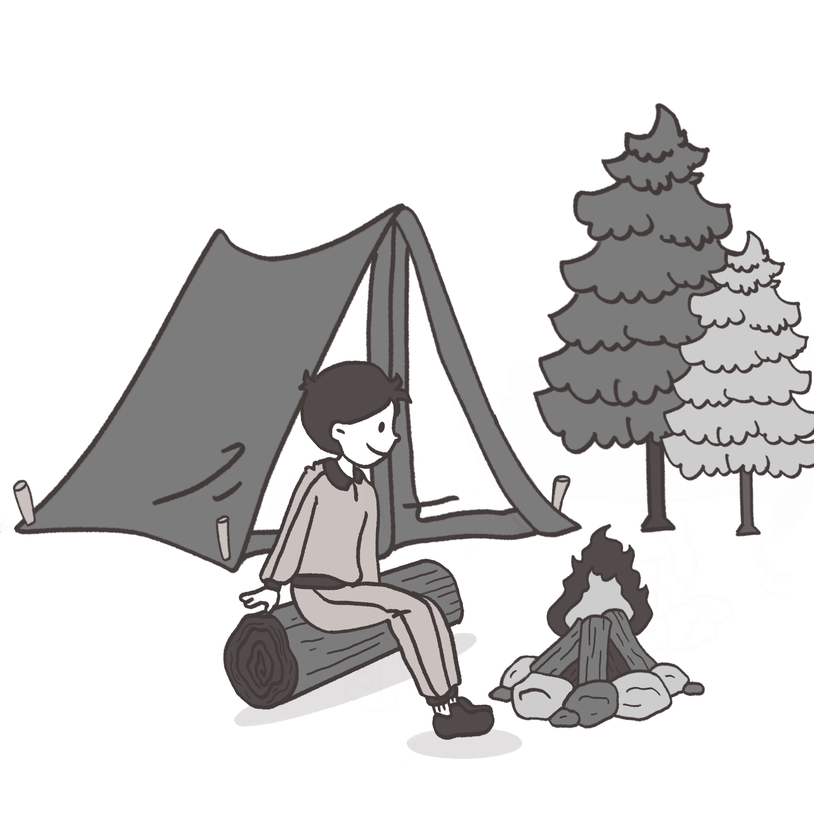
 | 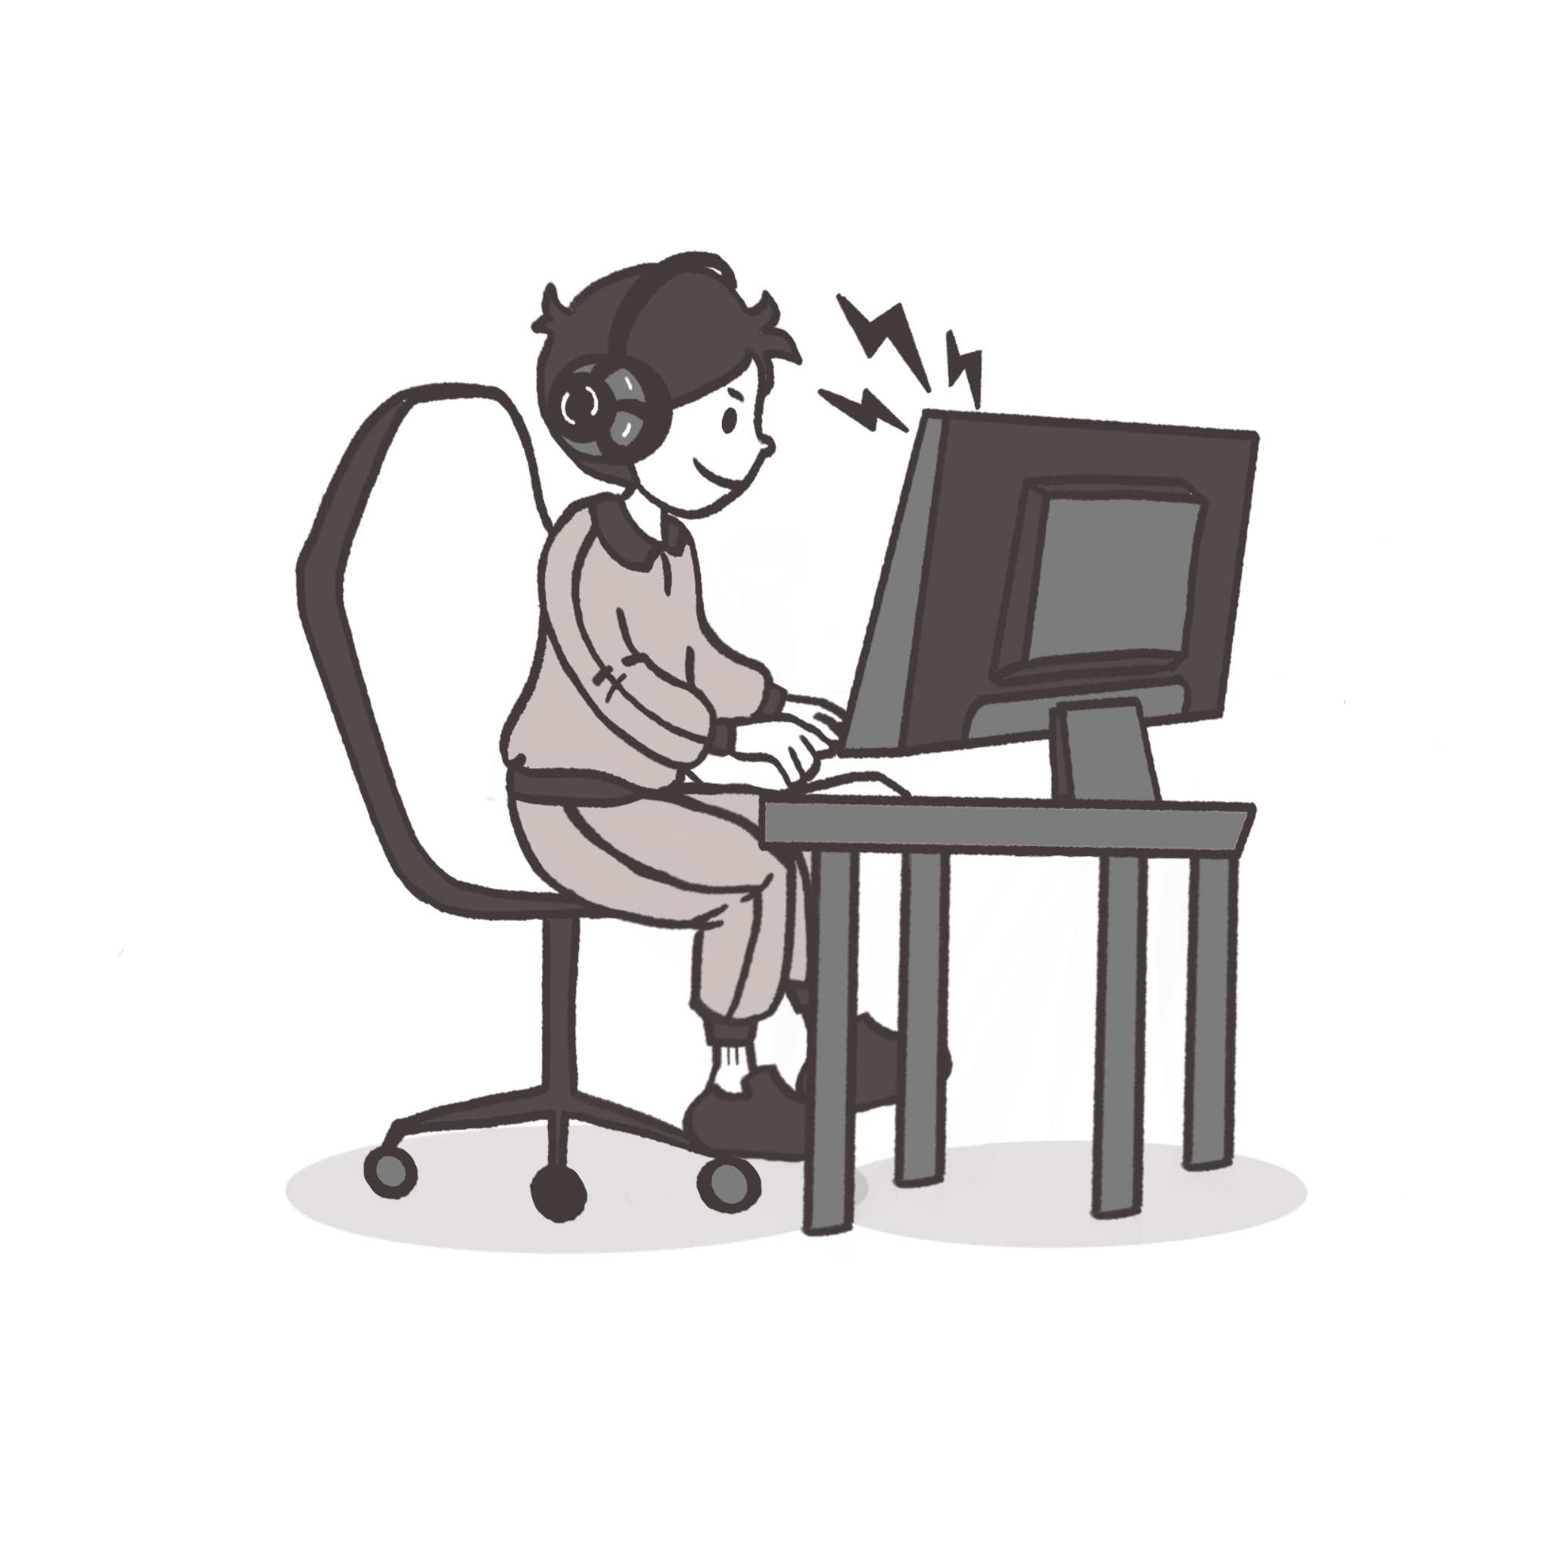

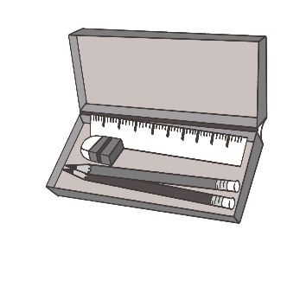 | 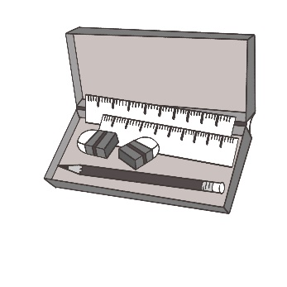
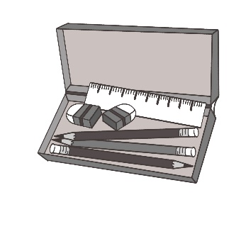 | 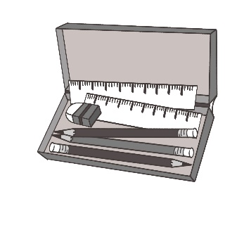

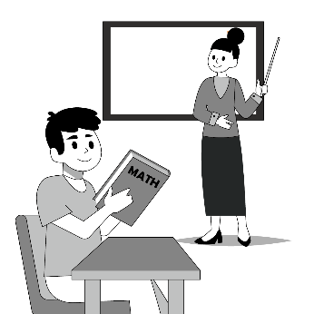 | 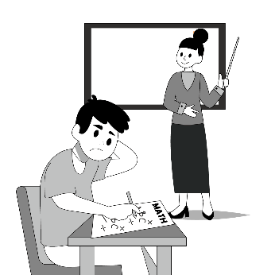
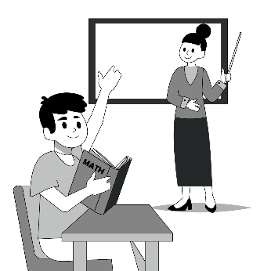 | 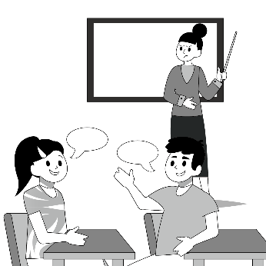

 | 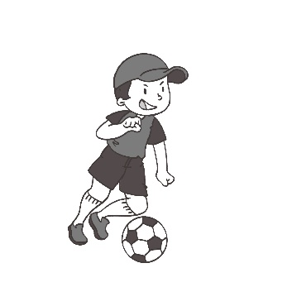
 | 

 | 
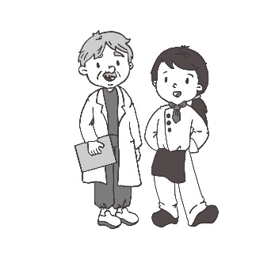 | 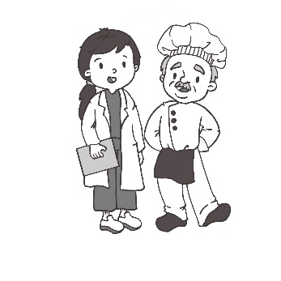

第二大題：基本問答（第6-10題）
作答說明：每題均有四個選項，請依據所聽到的內容，選出一個最適合的回應，每題播放兩次。

示例題：你會看到
Yes, I am angry.
No, I am happy.
Yes, I want a hamburger.
No, this is not a hamburger.

然後你會聽到．．．．．．（播音）。依據所播放的內容，正確答案應該選，請將答案卡該題「」的地方塗黑、塗滿：即 ●

Hurry up.
Get ready.
No problem.
That’s too bad.

I am hungry, too.
Let’s wait for Dad.
Do you like hamburgers?
We can make soup together.

That’s too much.
Five minutes more.
At about six o’clock.
Eight hundred dollars.

Yes, the zoo is new.
No, the animals are cute.
Yes, there are two baby elephants.
No, there aren’t any white rabbits.

Wow. You know a lot.
Wow. I don’t think so.
Wow. I seldom do that.
Wow. What time does she get up?

第三大題：言談理解（第11-15題）
作答說明：每題均有四個選項，請依據所聽到的對話或短文內容，選出一個最適合的答案，每題播放兩次。

示例題：你會看到
Thursday.
Friday.
Saturday.
Sunday.

然後你會聽到．．．．．．（播音）。依據所播放的內容，正確答案應該選，請將答案卡該題「」的地方塗黑、塗滿：即 ●

She is Judy’s new teacher.
She is Judy’s new classmate.
She is the man’s new classmate.
She is a new teacher in the school.

At home.
At a school.
At a fruit shop.
At a restaurant.

She never gets up early.
She enjoys working at night.
She works from Tuesday to Sunday.
She usually sleeps from 7 p.m. to 5 a.m.

The show starts at noon.
They are at a school show.
The show is about cellphones.
People can eat during the show.

She enjoys the movie.
She likes to drink coffee.
She works in the ticket office.
She comes to the wrong place.

各位同學，聽力測驗已經完成了，下一大題開始為閱讀測驗。
現在請翻到下一頁繼續完成作答。
第二部分：閱讀能力檢測，共20小題。

- Don’t __________ your finger at me like that. It is not nice.
point
break
touch
wash

- Amy: Why are you always early to school?
Tina: Our school is very __________ to my house. I can see it from my room. It’s only a one-minute walk away.
close
late
quiet
safe

- Jessica’s favorite month is __________. It comes before March.
January
February
April
May

- A: How about going camping tomorrow?
B: No way! It will be raining.
A: The day after tomorrow?
B: NO! Too windy and cold. Let me see. This Friday?
A: Cool!
How’s the weather this Friday?
Rainy.
Snowy.
Warm.
Windy.

- Pete: Why is Linda so angry now?
Rick: She wants to visit her friends, __________ she can’t. She has to look after her baby sister at home.
but
because
and
so

- Welcome to the museum. There are many special works of art here. Please don’t touch __________ take photos.
as
or
so
to

- This year, my twin brother has eleven candles on his birthday cake, and I __________, too.
am
do
has
have

- Sister: Tomorrow is Mother’s Day. __________ can make a cake and a card for __________.
Brother: Good idea. Let’s do it right now.
They; she
She; them
We; her
You; me

- (24-26)
Here is a note from Mom on Dora’s desk.
Dear Students,
Welcome to the school’s ‘Reading Room’. Please follow the rules. First, wash your hands before you read the books. 24 , but you can’t be too loud. You can drink water only, and you can’t eat. You can read all the books here, but you can’t 25 in them. It is ok to use the computer and your cell phone, but you can’t talk on the phone. And of course, you can’t run in here.
We are open during school hours. Every student can borrow 7 books at one time. You need to return them in two weeks. Go to talk to the ladies near the door if you have any questions. They are here to 26 everyone. I hope you have a wonderful time when you are here. Please come visit us whenever you have time. Enjoy!
Miss Chien
before在…之前 borrow借 return歸還 whenever無論何時

Be quiet
Walk fast
You can talk
They are different

get or give
work or use
check or call
write or draw

help
know
use
work

- (27-28)
 | Good evening. What are you doing? |  | 
 | I finished all my homework at school,  so I’m playing with my phone. You?
I am doing nothing. I am so bored.
Do you want to go to the movies with me?
I want to watch “The Beautiful Story.”
You want to go now?
Ok, but I don’t want to see that movie.
Yes. Right now!
Then, what do you want to watch?
 | I want to watch “Art Show.”
I am fine with that one, too.
How about “Blue Sky”?
Let’s go first and see what is on at the theater.
I need to be back at ten. Can we make it?
I think we can.
When do you need to leave the theater?
 | At 9:30.
I see.
Let’s meet at the front door
of the theater at seven.
Sure. Do you want to ask Doris Lin?
She looked sad after math class today.
 |  | Good idea. Let me ask her.
 | Good! See you later.
 |  | See you!
finished完成 bored無聊的 looked看起來(過去式) leave離開

- Movie Timetable -
The Beautiful Story | Art Show | Blue Sky | Love 101
2 hours | 2 hours | 2 hours 20 minutes | 2 hours 30 minutes
7:20 | 8:30 | 9:40 | 10:00

- What movie can they watch?
Art Show
Blue Sky
Love 101
The Beautiful Story

- Which is true?
They both know Doris Lin.
They do not go to the movies together.
They do not have any homework today.
They both want to watch “The Beautiful Story.”

- (29-31)
David and Ellen are brother and sister. They are junior high school students. Here is the schedule of their summer vacation. They need to go to school for club practice in the morning from Monday to Thursday. They are free after that.
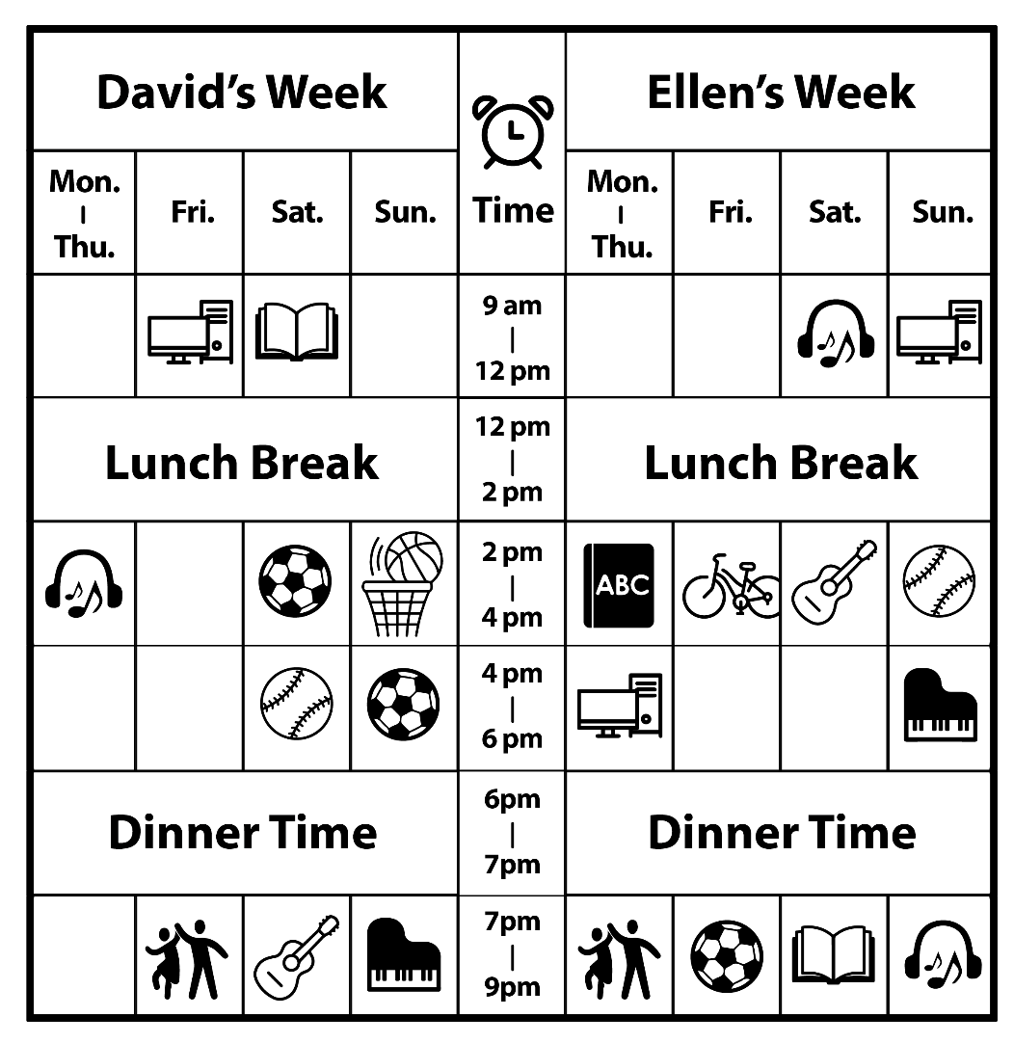
schedule 行程表
- __________ is Ellen’s favorite day of the week. She can play baseball, listen to music, and use the computer.
What day of the week is Ellen’s favorite?
Wednesday
Friday
Saturday
Sunday
- Frank is David’s classmate. They are talking online.
Frank: Are you free this weekend? I want to go to the museum for our summer homework.
David: What time?
Frank: In the afternoon. Saturday or Sunday is fine for me.
David: No, I can’t. I usually __________ at that time. Do you want to join me?
Frank: Sure. We can go to the museum another time.
David: Cool!
What is __________? Online線上
study
play sports
listen to music
use the computer

- __________ is David and Ellen’s favorite TV program. They always make time to watch it together every week. What program may it be?
 | Friday | Saturday | Sunday
14:00 – 16:00 | Cooking Story | Cooking Story | Cooking Story
16:00 – 18:00 | NBA Time | The X Files | Life in the USA
18:00 – 21:00 | Evening News | Sing with me | Evening News
Program節目
NBA Time
Sign with me
Cooking Story
Life in the USA

- (32-35)

Thank you for calling. Everyone is busy, so please wait. We are open from 9 am to 6 pm, but we are usually closed on Tuesday. People over 12 years old need to pay $300 per person. Children under 12 need to pay $150 each. Groups of more than 10 can have 20% off. You can park here, $100 for a car and $50 for a motorcycle. When you come, please watch your children carefully. Don’t get too close to the animals, and don’t feed them. If you are a fan of our superstars, the lions, you can come at 11:00, 13:00, or 15:00. If you are a bird lover, you can join us at 9:30 or 16:30. If you want to watch the magic sea animal show, please come at 10 am and don’t forget to bring a towel with you. You might get wet. Oh Oh…. We have this month’s special, the dog show, right after the morning birds show. Don’t miss that one! I hope you enjoy your time here. Thank you so much.
pay 付錢 fan粉絲 forget 忘記 towel 毛巾
- Matt is listening to this on the phone. Where is he calling?
Star Line
Cats Only
Zoo World
Phone Place

- Which timetable has the correct show times?
Birds show 9:30  *Dog show*  Sea animal show 10:00  Lion show 11:00  Lion show 13:00  Lion show 15:00  Birds show 16:30 |  | Birds show 9:30  Sea animal show 10:00  Lion show 11:00  Lion show 13:00  Lion show 15:00  Birds show 16:30  *Dog show*
Lion show 9:30  *Dog show*  Sea animal show 10:00  Lion show 11:00  Lion show 13:00  Birds show 15:00  Birds show 16:30 |  | Lion show 9:30  Sea animal show 10:00  Birds show 11:00  Birds show 13:00  Birds show 15:00  *Dog show*  Lion show 16:30
timetable 時間表
- Mr. and Mrs. Wang want to take their children there. Roger, the brother, is 14 years old, and Rosy, the sister, is 10 years old. They want to take the bus. How much do they need to pay?
$1000
$1050
$1100
$1150

- Which picture is correct?
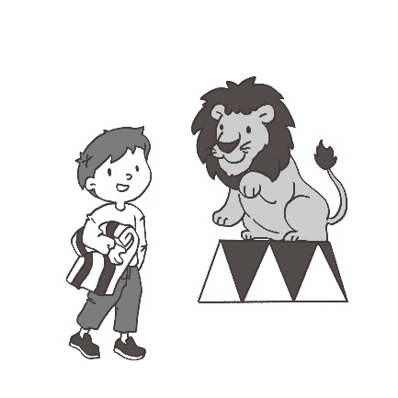 | 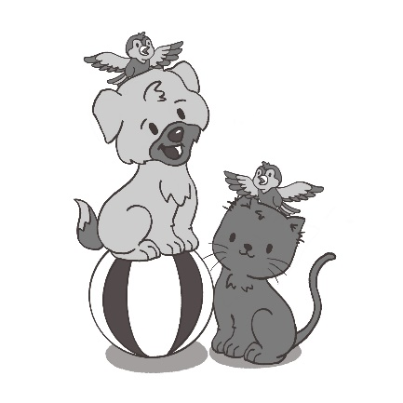
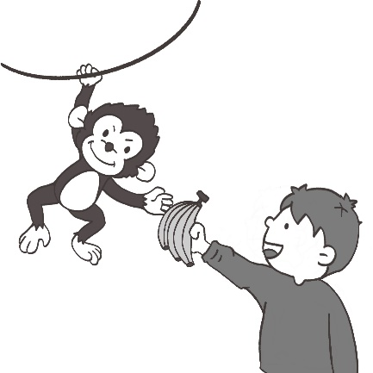 | 