112年學力檢測測驗題本
英語文八年級
作答注意事項：
各位同學：
你們好。
這是一份英語文的試題，總共35題。
第一個部分是15題聽力能力檢測，
第二個部分是20題閱讀能力檢測。
測驗時間為45分鐘。
每一題請選一個最合適的答案，並用2B鉛筆在答案卡畫記，不可超出格線外，如果需要修改答案，請用橡皮擦擦拭乾淨，再重新畫記。
畫記說明：
當你想選擇的答案為時，正確畫記為 ●
其他事項：
- 每一題都要回答。
- 試題如有錯誤，請立即告知老師。

學 校
班 級
座 號
姓 名
112年學力檢測測驗題本
英語文八年級聽力及閱讀測驗

各位同學，我們將要進行英語的聽力測驗和閱讀能力測驗。第一部分是聽力測驗共三大題，每一題都會先說明作答方式，請注意試題本上的例題，錄音說明完才會開始播放考試的題目。

每題會播放兩遍，題目不在試題本上，請依照聽到的內容，並看到各題的四個選項中，選出一個正確或最佳的答案，並畫記在答案卡上。錄音唸下一題時，你就要跟著做下一題。錄音會帶著你做完所有的聽力題目。開始作答後，請自行完成測驗，監考老師不會回答任何問題。但是你如果感覺身體不舒服，可以舉手向監考老師反應。

現在請翻頁。聽力測驗即將開始，請安靜並專心作答。
第一部分：聽力能力檢測，共三大題，15小題。
第一大題：辨識句意（第1-3題）
作答說明：請依據所聽到的句子，選出符合描述的選項，每題播放兩次。

示例題：你會看到
 | 
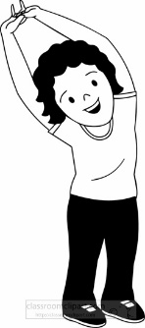 | 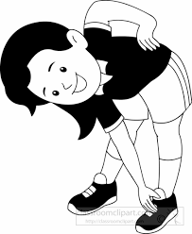

然後你會聽到．．．．．（播音）。依據所播放的內容，正確答案應該選，請將答案卡該題「」的地方塗黑、塗滿：即 ●

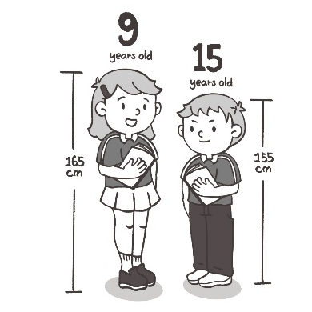 | 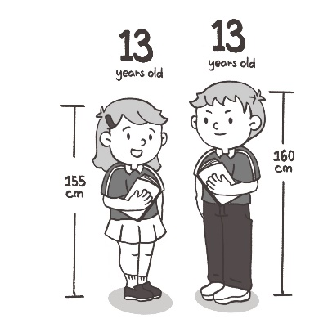
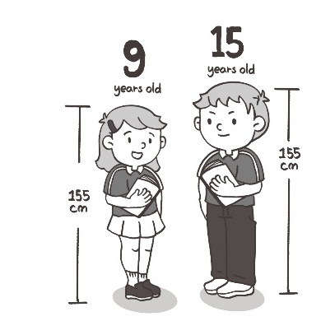 | 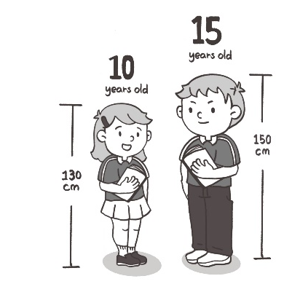

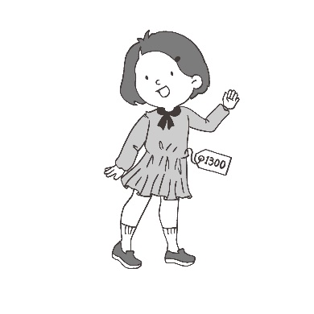 | 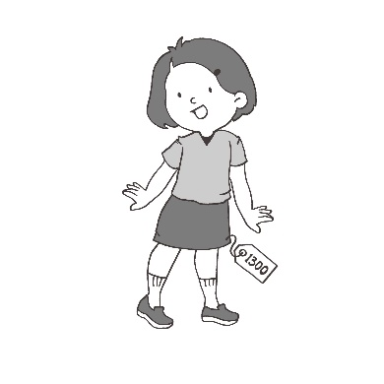
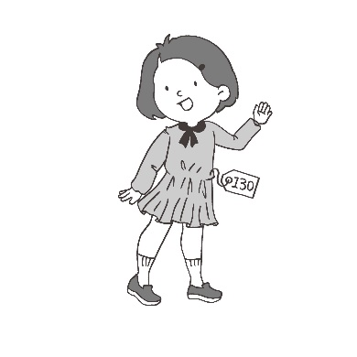 | 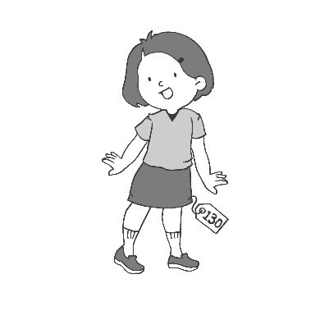

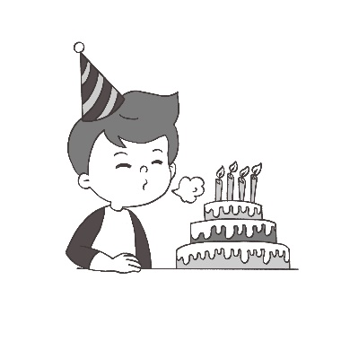 | 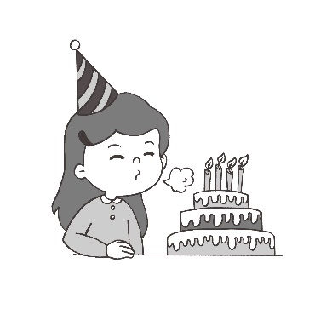
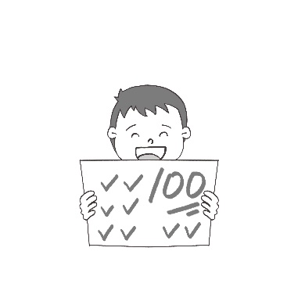 | 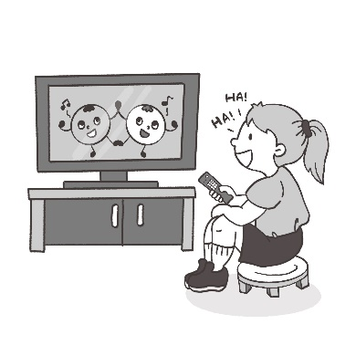

第二大題：基本問答（第4-9題）
作答說明：每題均有四個選項，請依據所聽到的內容，選出一個最適合的回應，每題播放兩次。

示例題：你會看到
Yes, I am angry.
No, I am happy.
Yes, I want a hamburger.
No, this is not a hamburger.

然後你會聽到．．．．．．（播音）。依據所播放的內容，正確答案應該選，請將答案卡該題「」的地方塗黑、塗滿：即 ●

Let’s buy a drink.
No, I don’t think so.
Yes, I met my old friend last weekend.
Why don’t you play online games at home?

Yes, it sounds horrible.
Sure, I am waiting for her.
Because I got one hundred.
No, I was afraid of telling her.

He sang beautifully.
No, he forgot to watch it.
Yes, he is a wonderful actor.
Wonderful! He danced well.

Sure. May I have your order?
Can you take a message for me?
It’s late. I will call in the morning.
Sure. May I ask who is calling again?

Yes, I love going there.
No, it is too dangerous.
Just go along for two blocks.
Can you buy me some bread?

In fact, I will stay here.
Staying in touch is good for us.
Yes, I was watching on Netflix.
No worries! Let me check it out.

第三大題：言談理解（第10-15題）
作答說明：每題均有四個選項，請依據所聽到的對話或短文內容，選出一個最適合的答案，每題播放兩次。

示例題：你會看到
Thursday.
Friday.
Saturday.
Sunday.

然後你會聽到．．．．．．（播音）。依據所播放的內容，正確答案應該選，請將答案卡該題「」的地方塗黑、塗滿：即 ●

Sleep in class.
Read a comic book.
Buy some ice cream.
Borrow science notes.

Dalia. She runs very slowly.
Ellen. She is in another class.
Chris. He is the slowest in our class.
Frank. He is also the tallest in our class.

Feeling surprised at something.
Having a strong interest in something.
Making people want to try new things.
Feeling unwell after eating or touching something.

It’s hot.
It’s cold.
It’s rainy.
It’s warm.

Cold.
Cool.
Hot.
Wet.

Read the cover first.
Get up early to help her dad.
Think more about everything.
Don’t wake Tim up during class.

各位同學，聽力測驗已經完成了，下一大題開始為閱讀測驗。
現在請翻到下一頁繼續完成作答。

第二部分：閱讀能力檢測，共20小題。

- Look at the picture. The boy is blowing the __________.
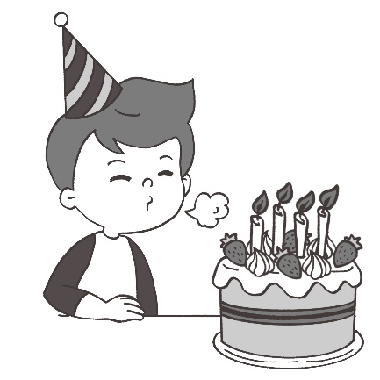
cake
candles
plate
strawberries

- Kevin’s father is good at __________. He always makes delicious meals and snacks.
cooking
driving
exercising
selling

- A great story like The Story of the Stone can pass the __________of time. People still read it after two hundred years.
man
test
line
play

- Henry still went to school this morning __________ he had a fever. This made his parents worried.
if
before
because
though

- Taipei 101 is 508 meters tall. It __________ workers five years to build it.
cost
paid
spent
took

- Here is a note on David’s desk.
Caller: Mr. Chen Date: May 15 Time: 15:00
Phone: 0856-4432
Will call again Please call Returned your call
Taken by Ariel

What should David do?
Call Ariel back.
Call Mr. Chen back.
Write a note to Ariel.
Wait for a call from Mr. Chen.

- Sally just bought a new house in Forest Park and she wrote a letter to her parents.
Dear Mom & Dad,
I would like to invite you to my new house this weekend. It is really a nice house. Out the back of it is a lake. There are beautiful trees all around. I can hear the sounds of birds in the morning and watch the evening sunshine. I can’t wait for you to come. See you!
With love,
Sally.

Which is Sally’s house?
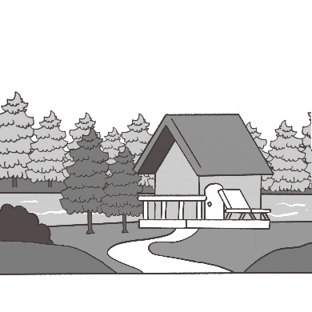 | 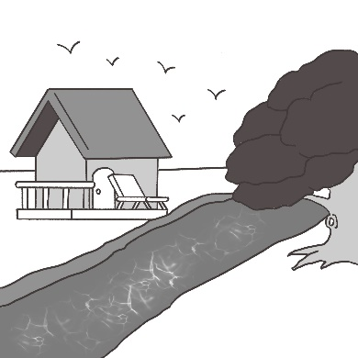
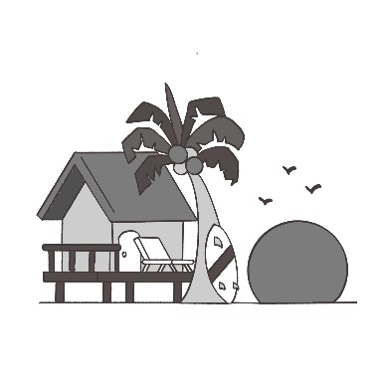 | 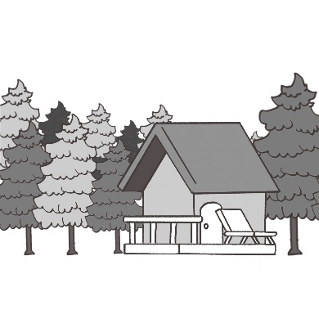

- (23-26)
(Marina and James are talking about their plans for summer vacation.)
Marina: | The summer vacation is coming. What are you 23 to do during the vacation?
James: | Well, you know I don’t like hot weather, so I’ll go to somewhere cool this summer.
Marina: | How does Australia sound? It 24 their winter then. I think it would be a great place to get away from the heat in Taiwan.
James: | Sounds like you have traveled there before.
Marina: | Yeah. I went there once. It’s also close to Taiwan. And it won’t 25 to fly there.
James: | That’s good. I can’t stand sitting on a plane for more than 10 hours. It could be a great place to 26 the summer vacation.
Marina: | Great! I’m sure you’ll have fun in Australia. Enjoy your trip.

plan
planning
plans
to plan

will
will be
will to be
is going to

have bad weather
let you sleep more
take you a long time
make your feel like at home

bring
cost
spend
watch

- (27-29)
Breaking News in Japan

The temperature in Tokyo went over 40°C for the first time in June. People are using their air conditioners more. Japan has asked people to use less electricity in the early evening hours. It wants people to turn off their lights from 3 p.m. to 6 p.m.
The heat wave will continue, and the rainy season is shorter than last year. This means the summer will be long and hot and there is a danger of heatstroke. The Japanese government has asked people to drink lots of water and not to exercise outside in the heat.
temperature 溫度 air conditioners冷氣 electricity電力

- What can we learn about the heat wave in Japan?
The rainy season is longer than last year.
It is much hotter in June because of the heat wave.
Using less electricity helps to raise the temperature.
Japan asks people to turn on lights in the early evening.

- What does heatstroke mean in the reading?
A health problem because of the hot weather.
A health problem because of staying inside too much.
A health problem because of the shorter rainy season.
A health problem because of drinking too much hot water.

- Japan wants people to use less electricity and save power. Which picture is better for advertising this? advertising 宣傳
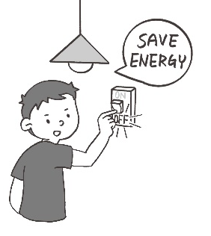 | 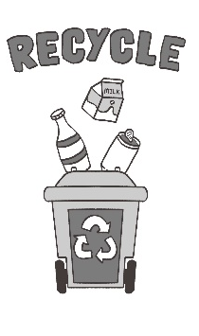 |  | 
- (30-32)
Having a good eating habit
Some people in Taiwan have trouble keeping fit. They usually get their favorite foods from restaurants or convenience stores. However, the food there is often full of calories. Having good eating habits helps us to stay healthy. What’s more, doing exercise every day is important. Here are some tips for you to follow.
- Have three meals a day, and no snacks between meals.
- Drink at least 2,000 c.c. of water every day.
- Have meat, vegetables and fruit in your diet. Stay away from fast food.
- Don’t be a couch potato. Try to spend more time doing outdoor activities, such as jogging, hiking, mountain climbing, biking and swimming.
- Go to bed early. Don’t stay up late. Resting your body makes you feel new the next morning.
keep fit 保持身材 calories卡路里
- Linda wants to keep fit. Which one is better for her?
She should eat out for every meal.
She should eat more meat than vegetables.
She should exercise more and stay away from fast food.
She should spend long hours sitting in front of the computer.

- Who might need healthy eating habits and lifestyle?
Anne, who likes eating fast food and watching TV.
Judy, who always has fruit and vegetables in her diet.
Ben, who exercises every day and drinks a lot of water.
Kevin, who goes to bed early and seldom eats snacks between meals.

- Which is NOT an outdoor activity?

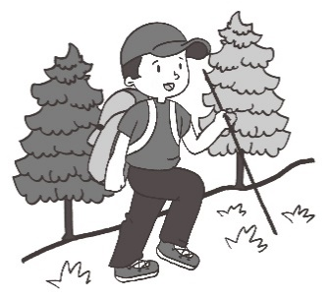 | 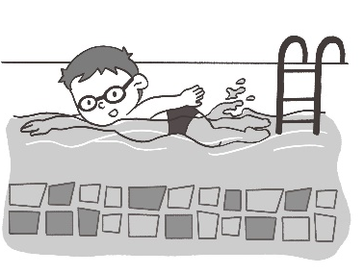 | 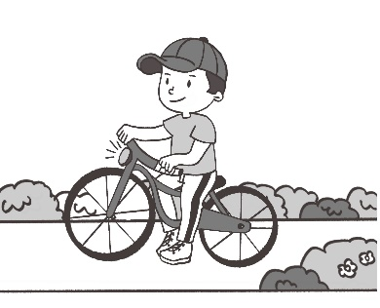 | 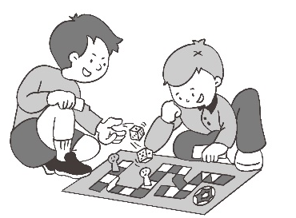

- (33-35)
How do seabirds share?
Most seabirds live in large groups with many different kinds of birds. This is safer than living alone because it keeps them safe from predators. But there’s a problem, all the birds like to eat fish. If the seabirds want to live together without fighting, they have to share their food with others. Scientists study a seabird group with:
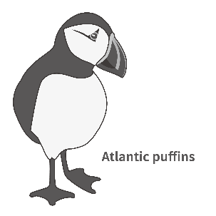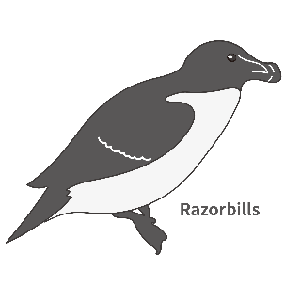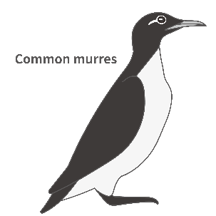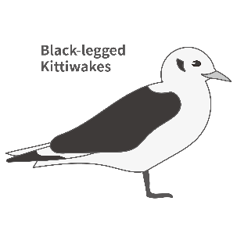
Figure 1
These four types of birds (see Figure 1) have the same in some places, but also different in some ways. Puffins, razorbills, and murres can dive. Kittiwakes can’t, so they only catch fish swimming near water. Razorbills hunt close to their nests, but kittiwakes fly farther away to find food (see Figure 2). Murres can find bigger fish and eat different kinds of fish. This is because they can dive deeper than the other seabirds. At first the scientists thought they all ate the same fish and would get into fights over food. But the study shows they have small differences in their lifestyles meaning they can share the tasty fish. These differences make them live together without fighting for food (fish).
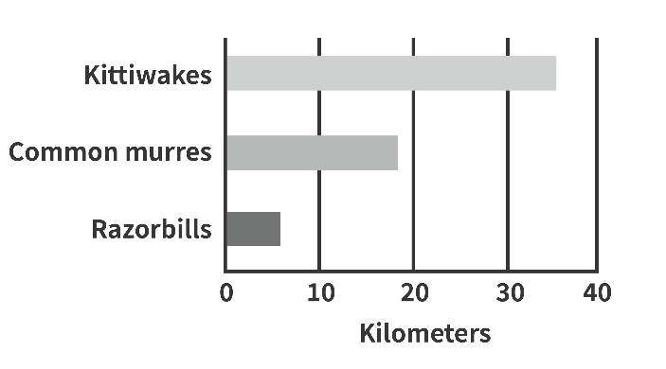
How far away from the nest the seabirds fly
Figure 2
alone 獨自的 predator 掠食者 scientist 科學家 dive潛水 nests巢穴

- What is the reading about?
How to study seabirds.
How far away the seabirds can fly.
How different types of seabirds share.
Which type of seabirds can dive deepest.

- Which seabird can dive the deepest?
Atlantic puffins.
Razorbills.
Common murres.
Black-legged kittiwakes.

- Which is true?
Both puffins and razorbills can dive.
Kittiwakes can dive and swim in the water.
Murres can only find smaller fish near the surface.
Razorbills like to fly farther away from their nests.

