113年學力檢測測驗題本
英語文八年級
作答注意事項：
各位同學：
你們好。
這是一份英語文的試題，總共35題。
第一個部分是15題聽力能力檢測，
第二個部分是20題閱讀能力檢測。
測驗時間為45分鐘。
每一題請選一個最合適的答案，並用2B鉛筆在答案卡畫記，不可超出格線外，如果需要修改答案，請用橡皮擦擦拭乾淨，再重新畫記。
畫記說明：
當你想選擇的答案為時，正確畫記為 ●
其他事項：
- 每一題都要回答。
- 試題如有錯誤，請立即告知老師。

學 校
班 級
座 號
姓 名
113年學力檢測測驗題本
英語文八年級聽力及閱讀能力檢測

各位同學，我們將要進行英語的聽力能力檢測和閱讀能力檢測。第一部分是聽力能力檢測，共三大題，每一題都會先說明作答方式，請注意試題本上的例題，錄音說明完才會開始播放考試的題目。

每題會播放兩遍，題目不在試題本上，請依照聽到的內容，並看到各題的四個選項中，選出一個正確或最佳的答案，並畫記在答案卡上。錄音唸下一題時，你就要跟著做下一題。錄音會帶著你做完所有的聽力題目。開始作答後，請自行完成測驗，監考老師不會回答任何問題。但是你如果感覺身體不舒服，可以舉手向監考老師反應。

現在請翻頁。聽力能力檢測即將開始，請安靜並專心作答。
第一部分：聽力能力檢測，共三大題，15小題。
第一大題：辨識句意（第1-3題）
作答說明：請依據所聽到的句子，選出符合描述的選項，每題播放兩次。
示例題：你會看到
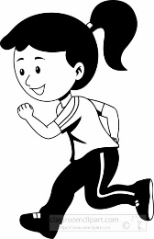 | 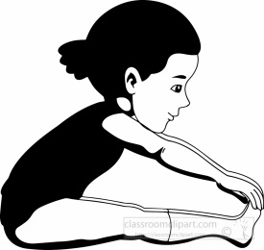
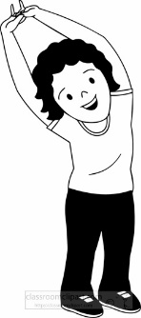 | 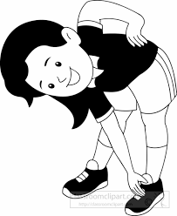

然後你會聽到．．．．．（播音）。依據所播放的內容，正確答案應該選，請將答案卡該題「」的地方塗黑、塗滿：即 ●

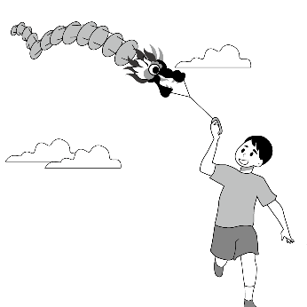 | 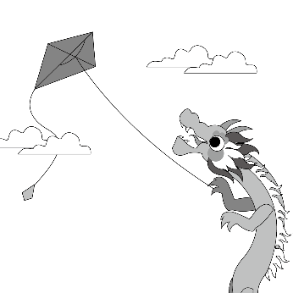
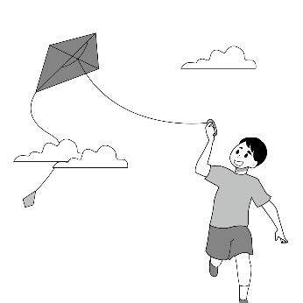 | 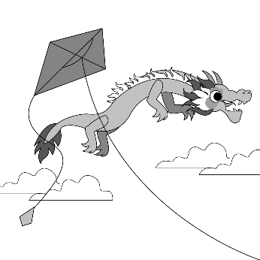

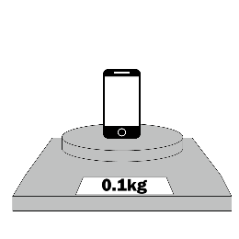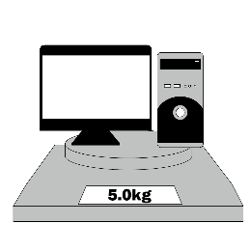 | 
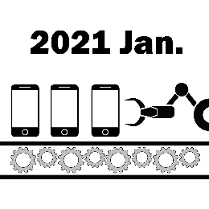 | 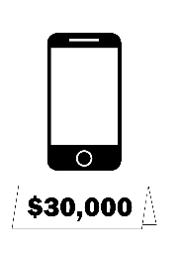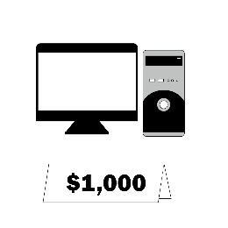

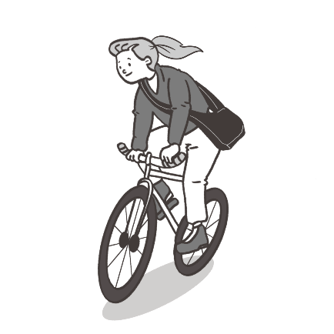 | 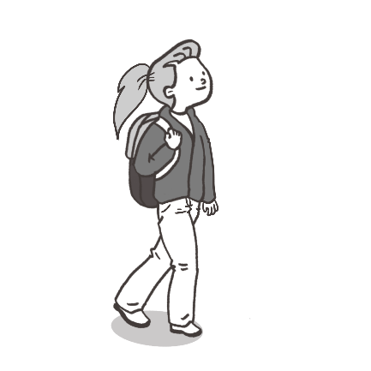
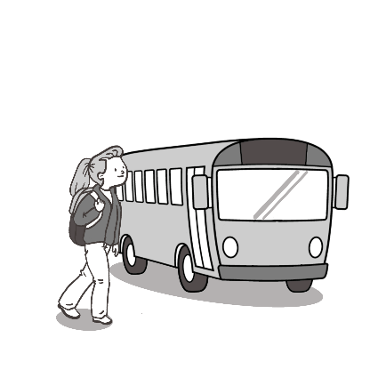 | 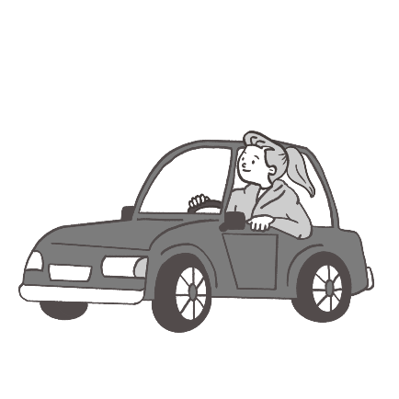

第二大題：基本問答（第4-9題）
作答說明：每題均有四個選項，請依據所聽到的內容，選出一個最適合的回應，每題播放兩次。

示例題：你會看到
Yes, I am angry.
No, I am happy.
Yes, I want a hamburger.
No, this is not a hamburger.

然後你會聽到．．．．．．（播音）。依據所播放的內容，正確答案應該選，請將答案卡該題「」的地方塗黑、塗滿：即 ●

About thirty minutes.
Almost every month.
At six o’clock.
It tastes good.

Yes, I want to sleep there.
Yes, let’s go to the supermarket.
No, I want to go there with my friend.
No, you need to take Bus 201 and get off on Park Road.

Good for you!
The blue one is perfect.
Of course. It’s your gift.
Yes, it should look good on me.

It will start at seven.
That is very popular.
It’s one thousand NT dollars.
It took me three hours to buy it.

Let’s sweep the floor together.
You can take out your cellphone.
An earthquake! Hide under the table.
You can jump up and down on the floor.

The shorts are cheap.
The skirt is too short.
The shirt is not big enough.
It is a present from my grandma.

第三大題：言談理解（第10-15題）
作答說明：每題均有四個選項，請依據所聽到的對話或短文內容，選出一個最適合的答案，每題播放兩次。

示例題：你會看到
Thursday.
Friday.
Saturday.
Sunday.

然後你會聽到．．．．．．（播音）。依據所播放的內容，正確答案應該選，請將答案卡該題「」的地方塗黑、塗滿：即 ●

He has a school test.
He has a music lesson.
He has a baseball game.
He has a video game club.

Because he failed the test.
Because his mom yelled at him.
Because he had a fight with his mom.
Because he should say sorry to the girl.

Going window shopping.
Fixing the washing machine.
Buying a new washing machine.
Selling the old washing machine.

Hospital.
Supermarket.
Library.
Bank.

In a car.
On a train.
On a phone.
On a scooter.

She is not interested.
She finds it a good deal.
She thinks it’s expensive.
She feels unhappy with the price.

各位同學，聽力能力檢測已經完成了，下一大題開始為閱讀能力檢測。
現在請翻到下一頁繼續完成作答。

第二部分：閱讀能力檢測，共20小題。

- Lily three hours making a birthday cake for her younger sister.
cost
paid
spent
took

- Sharon enjoys __________ in her free time. She has many beautiful paintings.
drawing
reading
dancing
singing

- Alice wants to be a __________ because she loves to grow vegetables and fruits on the land.
cook
doctor
farmer
reporter

- Look at the picture. The woman is __________ her dog in the park.
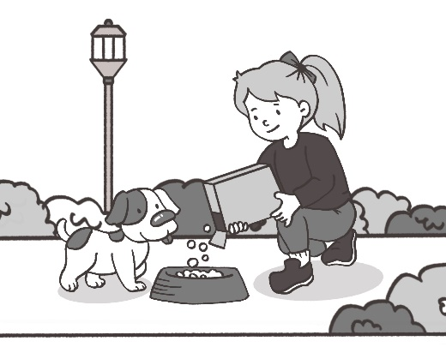
carrying
feeding
hitting
walking

- Jason is going to hike in the mountain next week. The weather will be cold and windy.
What should he wear?
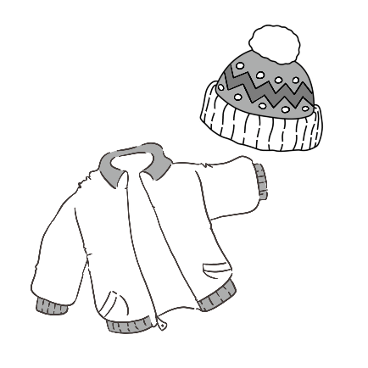 | 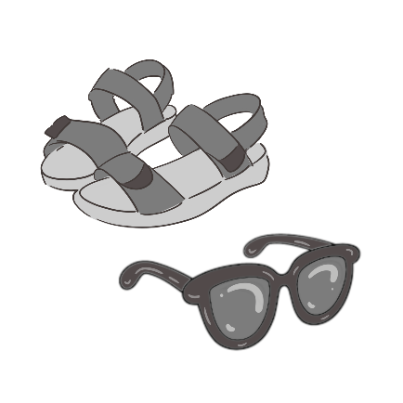
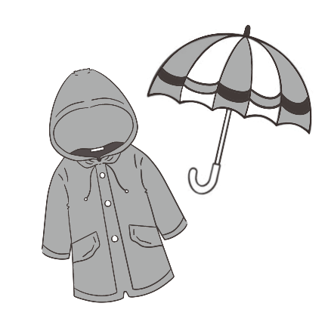 | 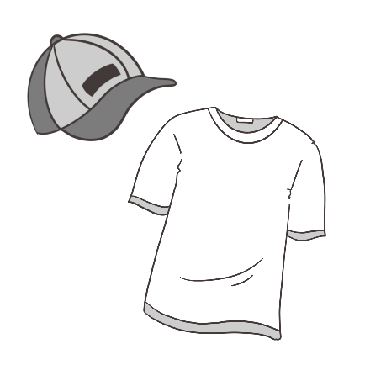

- Bella: Break a leg, Ethan. I am sure your show will be great tonight!
Ethan: Thanks! Hope you enjoy it.

Break a leg means you hope someone will __________.
have a break
hurt their leg
have a good luck
hurt their feelings

- (22-25)
The Story of Lionel Messi
Lionel Messi was born on June 24, 1987, in Argentina. No one thought one day he 22 one of the greatest footballers in history. He started playing football when he was very young and showed he was really good at it. When Messi was 11, his parents found out he had a health problem called growth hormone deficiency (GHD), and he needed 23 medicine for it. Luckily, Barcelona Football Club in Spain helped pay for his medicine. Messi and his family were happy about this, so they decided to move to Barcelona.
Messi was the youngest player for Barcelona Football Club and also played for Argentina's national team. Though he was only 1.7 meters tall and weighed 67 kilograms, 24 . At the age of 16, he played his first match and helped Argentina win. He became famous for playing for Barcelona and Argentina. In 2009, Messi won his first Ballon d'Or, the best football player in the world that year. 25 . In 2022, he won another big prize called the World Cup’s Golden Ball, and he is the first player to get it twice. “You have to fight for your dream,” Messi said. He never gives up and always tries hard to be better. Messi's story teaches us to keep trying even when things are difficult.
footballer足球運動員 growth hormone deficiency (GHD)侏儒症 match比賽

become
becomes
will become
would become

convenient
expensive
famous
strange

he had many close friends
he went to bed early every day
he could swim faster than others
he was strong, fast, and hard-working

He always wanted to do better
He changed his football team many times
He seldom practiced with other players
He spent more time with his family

(26-28)
We often say “as busy as a bee,” but do you know how bees have fun? Scientists wanted to know more about bees, so they did some tests with them. They found that they liked playing with small balls, just like humans. Young bees played with more balls than old bees. The boy bees play with balls longer than the girl bees.
In the tests, there were 45 bumblebees. These bees had two choices to make. The first choice was to go straight to a sweet treat. The second choice was to go around small balls before they get to the treat. Surprisingly, most of the bees decided to play with the balls first before they enjoyed their sweet treat. Scientists said bees have feelings, and their minds are smarter than we thought.
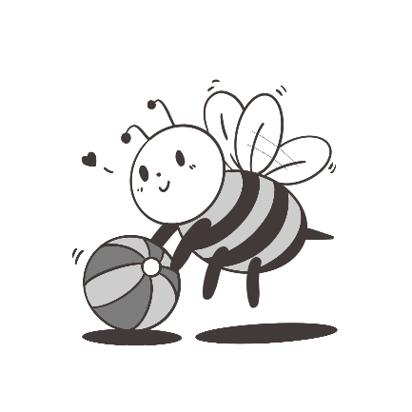
bumblebees大黃蜂 choice 選擇 mind大腦、智力

- Why did scientists do tests with bees?
To see how fast bees fly.
To find out how bees play.
To understand where bees live.
To learn about what bees like to eat.

- In the reading, what did most of the bees do in the tests?
Eat the balls first, and fly away.
Sleep first, then play with the balls.
Choose the sweet treat first without playing.
Play with the balls first, then go for the treat.

- According to scientists, what did they say about the minds of bees?
Bees are wiser than we thought.
Bees have simple minds.
Bees have no feelings.
Bees cannot think.

(29-32)
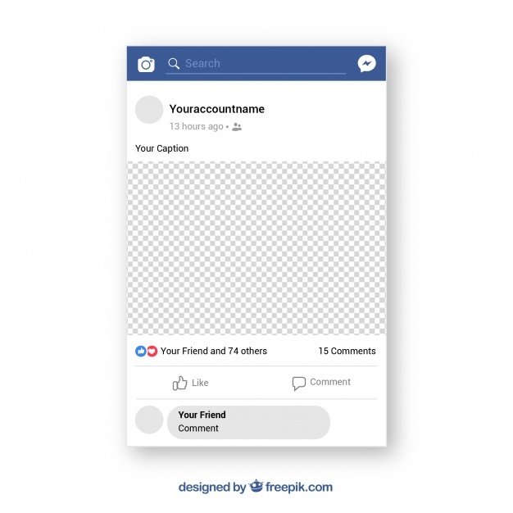
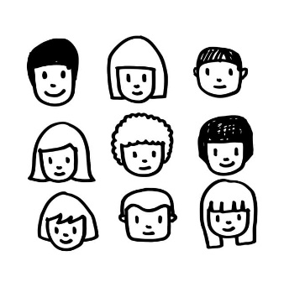 |  | Alice  15 hours ago
Hey, guys. The school is going to cut down the giant trees by the gym to build a new swimming pool. What do you think?

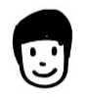 | Eddie  No way! The giant trees are very important. They are more than one hundred years old.
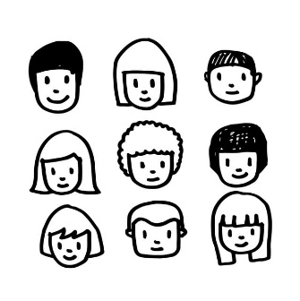 | Doris  We need a swimming pool, but I don’t want the school to cut down the trees.  Can the school build the swimming pool somewhere else?
Mia
We don’t have any other space for the pool. We can ask the school to move the giant trees to other places.
Nancy
@Mia. I think so, too. Let’s speak to the teachers tomorrow. It is our dream to have our own swimming pool.
George
I can’t swim, so I don’t need it. And there are many birds and small animals in the trees. We can’t cut down their homes!
Hank
The school swim team needs the new swimming pool.
Right? @Doris, @Mia, @Nancy
It takes us one hour to get to the nearest swimming pool every day. The new pool will be great for us.
giant 巨大的 swimming pool 游泳池
- Why does the school want to build a new swimming pool?
The swimming pool is too old.
The school team and the students need it.
The swimming pool is good for the animals.
The school wants to cut down the giant trees.

- Who is NOT on the school swim team?
Doris.
George.
Hank.
Nancy.

- What may Mia and Nancy do the next day?
They may look for the small animals in the trees.
They may ask their friends to join the school swim team.
They may ask the teachers to move the trees to other places.
They may look for another place to build the swimming pool.

- Which is true?
Alice wants a new swimming pool.
The giant trees are more than 1000 years old.
Doris thinks it is a good idea to cut down the giant trees.
It takes Hank sixty minutes to get to the swimming pool.

- (33-35)
Last night I flew in outer space
I flew so fast and far.
A ship tried to race
Me around a shining star.

Last night I had a pair of wings
But still I couldn’t fly.
I had to watch other things
Like birds flying by!

Last night I helped a dragon
Without giving the fire.
I gave it chili peppers
And watched the fire shoot higher.

Last night I found some magic shoes
Making me feel so tall.
I jumped so high I couldn’t lose
When I played basketball.

Last night I painted my town
In colors bright.
Red, yellow, and brown
What a beautiful sight.

Each night in my bed
I can’t wait to see.
The inside my head
What will they be?
outer space 外太空 wing翅膀 chili pepper辣椒
- How does the speaker feel when wearing the magic shoes?
Afraid.
Excited.
Sad.
Tired.

- What didn’t the speaker do in the reading?
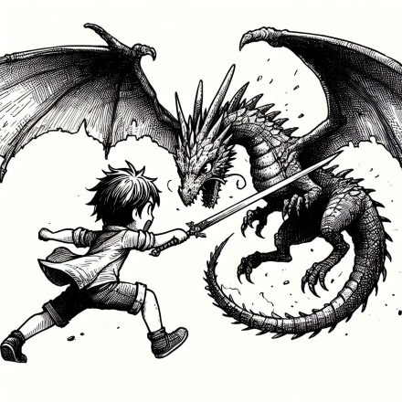 | 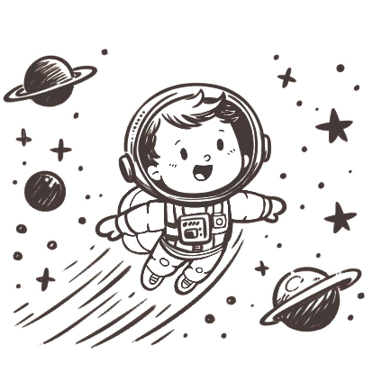
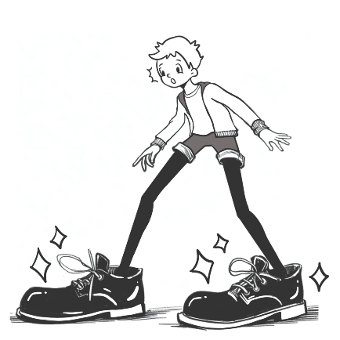 | 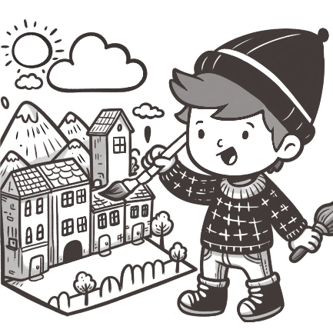

- What might be “ ” in the reading?
dreams
gardens
movies
voices

