113年學力檢測測驗題本
英語文五年級
作答注意事項：
各位同學：
你們好。
這是一份英語文的試題，總共35題。
第一個部份是15題聽力能力檢測，
第二個部份是20題閱讀能力檢測。
測驗時間為40分鐘。
每一題請選出一個最合適的答案，並用2B鉛筆在答案卡畫記，不可超出格線外，如果需要修改答案，請使用橡皮擦擦拭乾淨，再重新畫記。
畫記說明：
當你想選擇的答案為時，正確畫記為① ② ③ ●
其他事項：
- 每一題都要回答。
- 試題如有錯誤，請立即告知老師。

學 校
班 級
座 號
姓 名
113年學力檢測題本
英語文五年級聽力及閱讀能力檢測

各位同學，我們將要進行英語的聽力能力檢測和閱讀能力檢測。
第一部分是聽力能力檢測，
會先說明作答方式，請注意試題本上的例題，錄音說明完才會開始播放考試的題目。每題會播放兩遍，題目不在試題本上，請依照聽到的內容，並看到各題的四個選項中，選出一個正確或最佳的答案，並畫記在答案卡上。

錄音唸下一題時，你就要跟著做下一題。錄音會帶著你完成所有的聽力題目。
開始作答後，請自行完成測驗，監考老師不會回答任何問題。
但是如果你感覺身體不舒服，可以舉手向監考老師反應。

現在請翻頁。聽力能力檢測即將開始，請安靜並專心做答。

第一部分：聽力能力檢測，共二大題，15小題。

第一大題：聽辨字音、辭彙和句子
【說明】
請依據所聽到的辭彙、句子和敘述，選出最適當或相關的答案與回應，將答案的號碼塗在答案卡上，每一題會重複唸兩次，共8小題。

【例題】
聽到單字：rabbits, rabbits
看到選項：① snakes ② dogs ③ cats ④ rabbits
選出正確答案：④

現在請開始作答。

1. | ① pill | ② Phil | ③ hill | ④ wheel
2. | ① bait | ② bake | ③ bad | ④ date
3. | ① nine | ② nineteen | ③ ninety | ④ night

4. | ① | ② | ③ | ④
 |  |  | 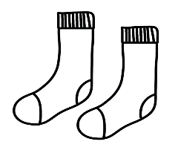 | 

5. | ① Two hundred and fifteen | ② Two hundred and twenty-five
 | ③ Two hundred and fifty-five | ④ Three hundred and fifty-five
6. | ① |  | ②
 | 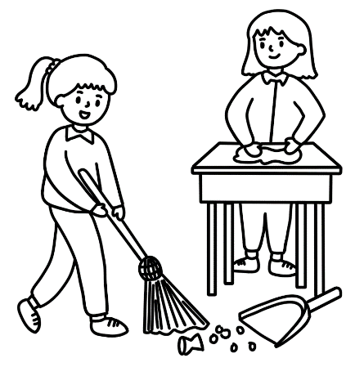 |  | 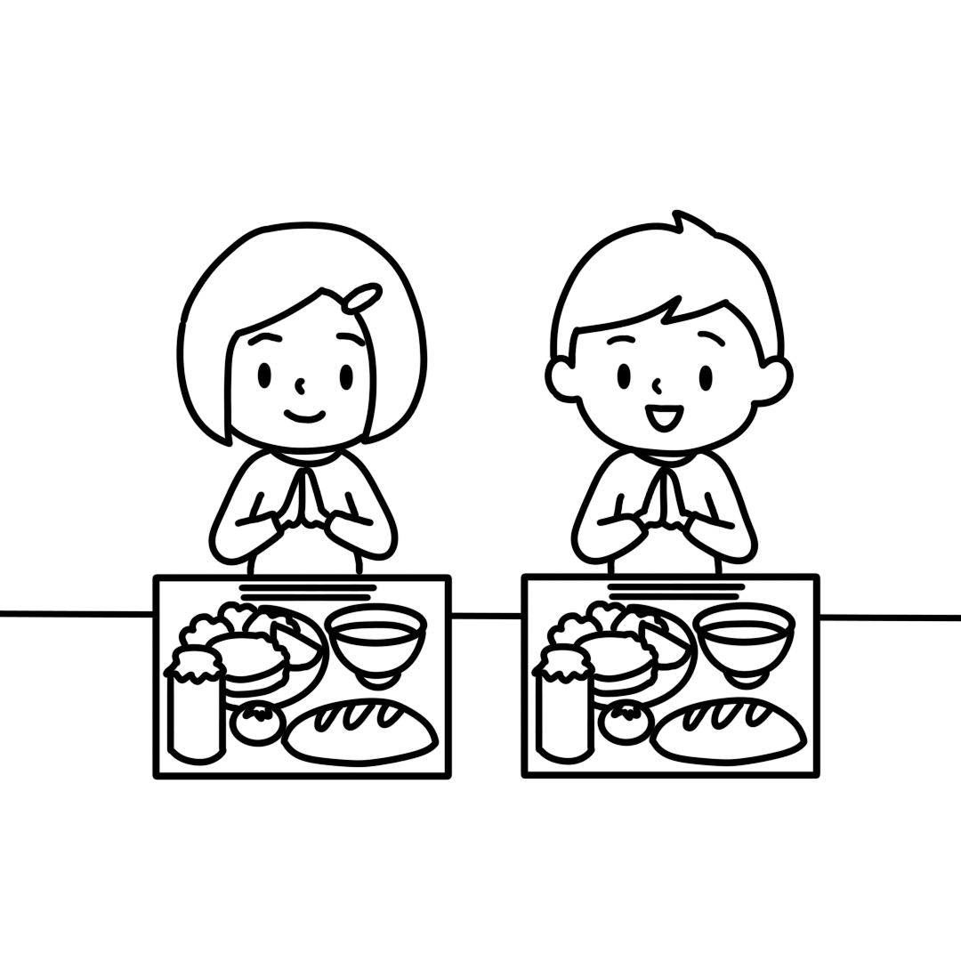
 | ③ |  | ④
 | 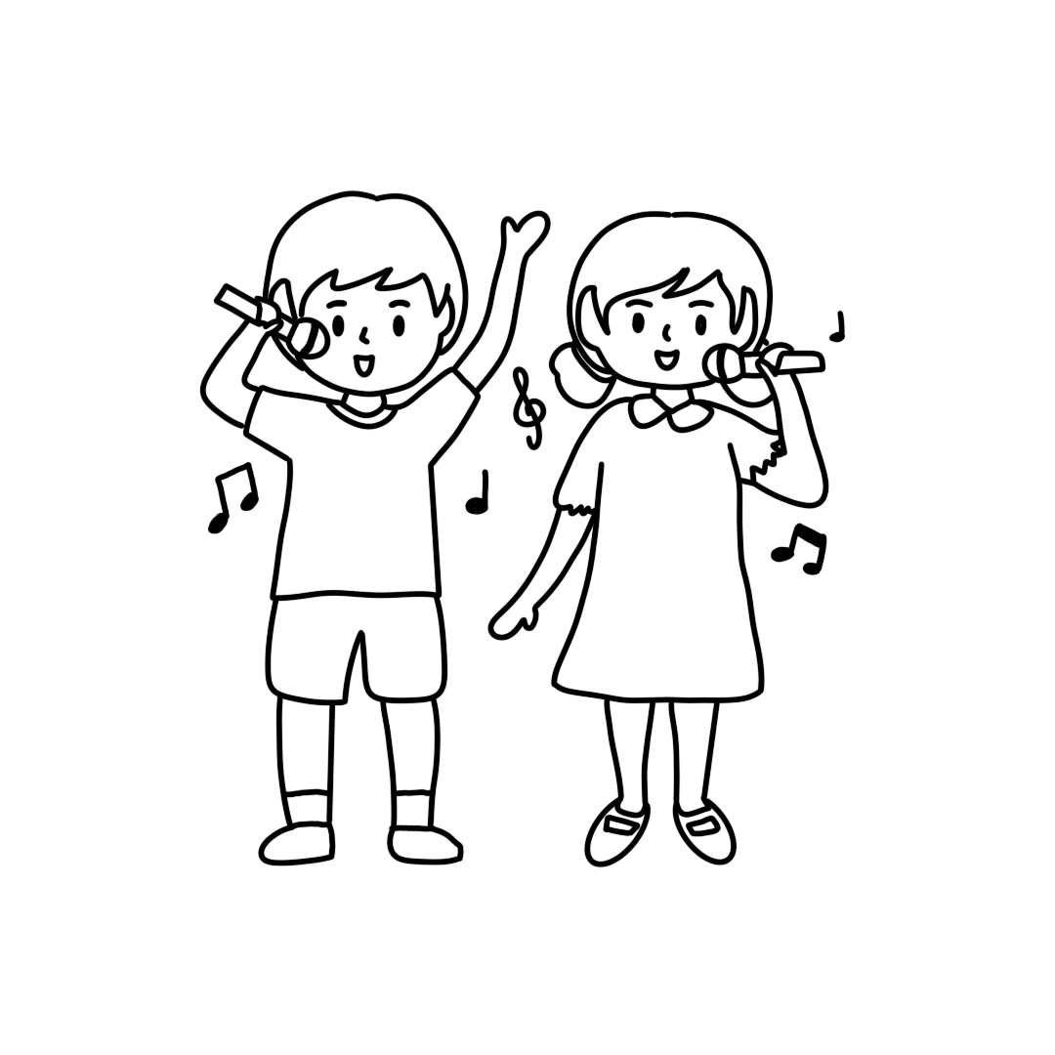 |  | 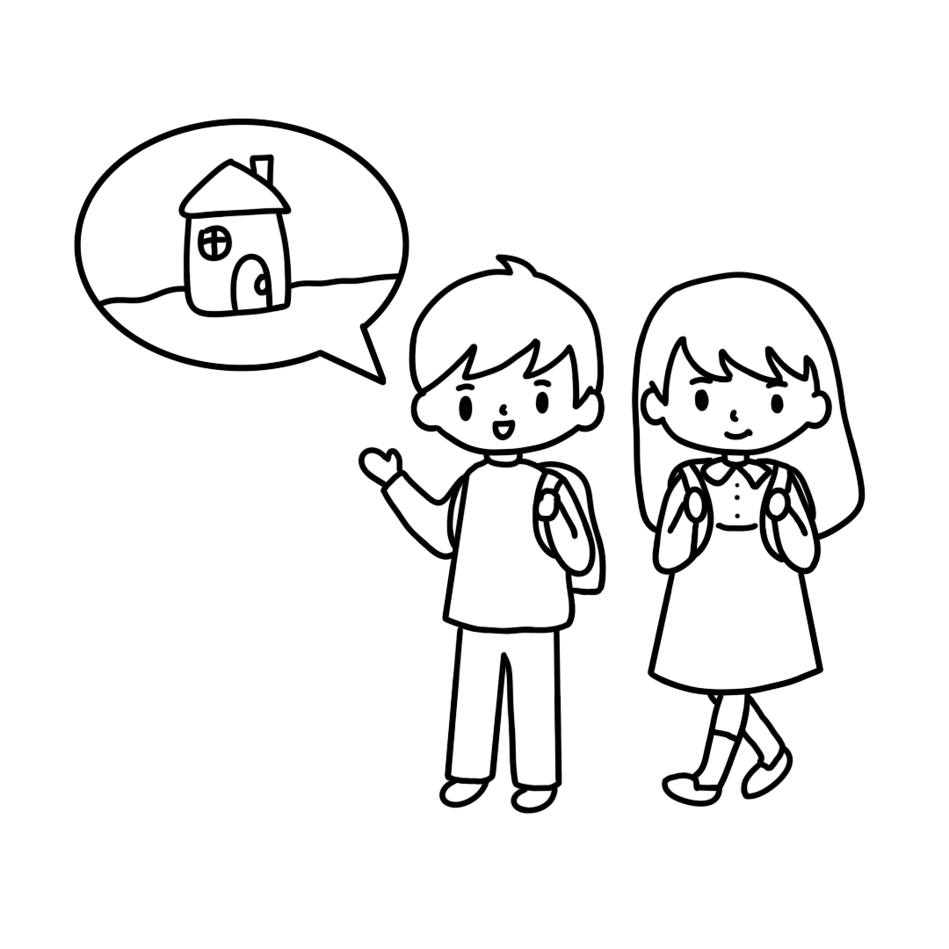

7. | ① | ②
 | 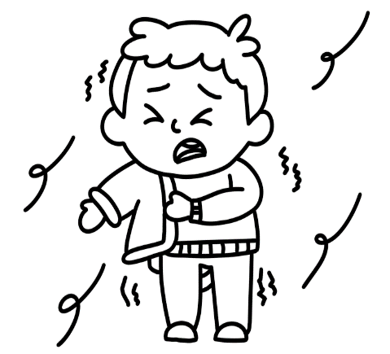 | 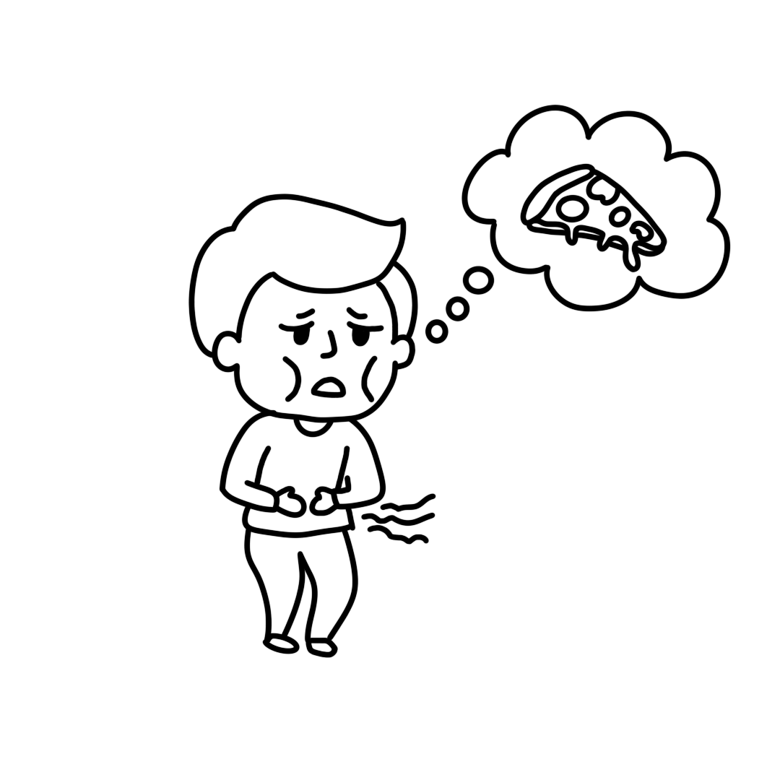
 | ③ | ④
 | 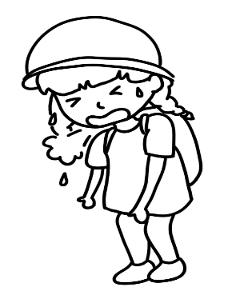 | 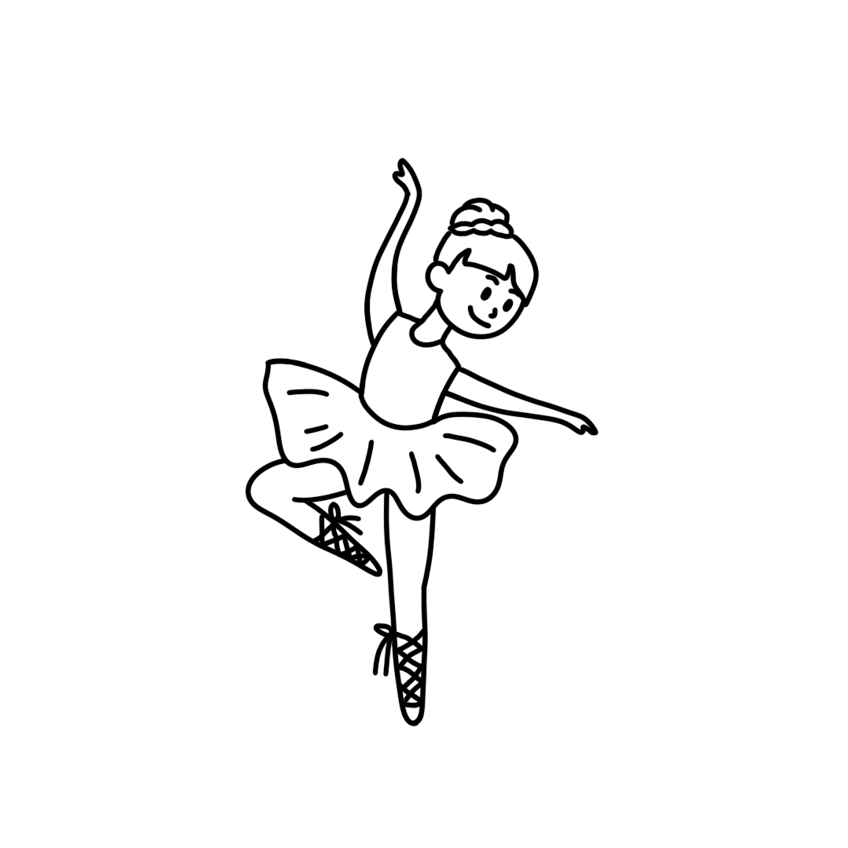
8. | ① | ②
 | 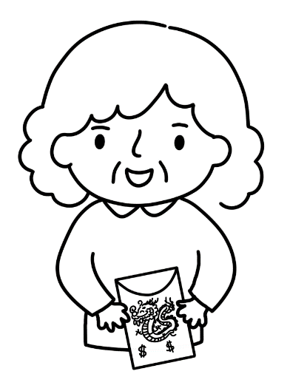 | 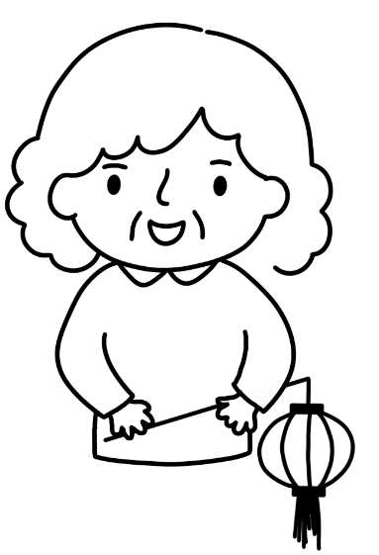
 | ③ | ④
 | 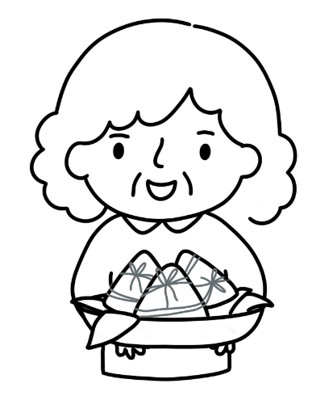 | 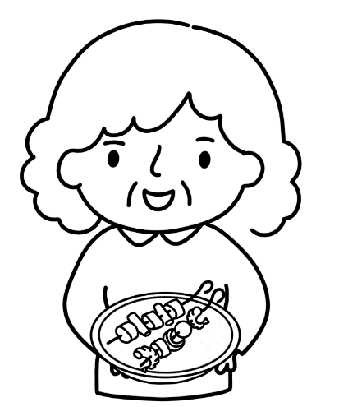

第二大題：生活辭句回應
【說明】
請依據所聽到的句子或問句，選出最適當的回應，並將答案的號碼塗在答案卡上，每一題會重複唸兩次，共7小題。

9.
- Amy, are you okay?
- Amy, what time is it?
- You are welcome, Amy.
- Thank you very much, Amy.

10.
September 10th
Time | 7:30 AM | 4:00 PM | 6:00 PM | 9:00 PM
Things to Do | Go to school | Go home | Have dinner | Go to bed

- It’s six o’clock.
- It’s seven thirty.
- It’s nine o’clock.
- Yes, he is.
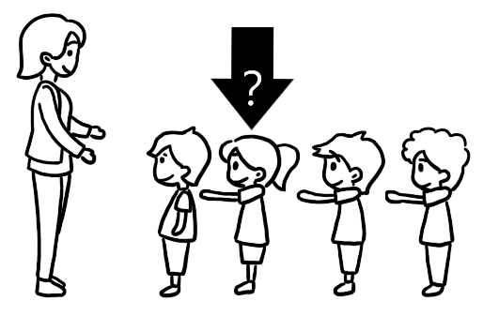
11.
- She is Judy.
- She is nine.
- She is next to Andy.
- She is the teacher.

12.
- He’s in the living room.
- He’s in the kitchen.
- He’s in the car.
- He’s in the library.

13. | ① | ②
 | Shopping List  □Oranges  □Grapes  □Guavas | Shopping List  □Oranges  □Apples  □Lemons
 | ③ | ④
 | Shopping List  □Oranges  □Apples  □Bananas | Shopping List  □Papayas  □Grapes  □Bananas

◆14-15
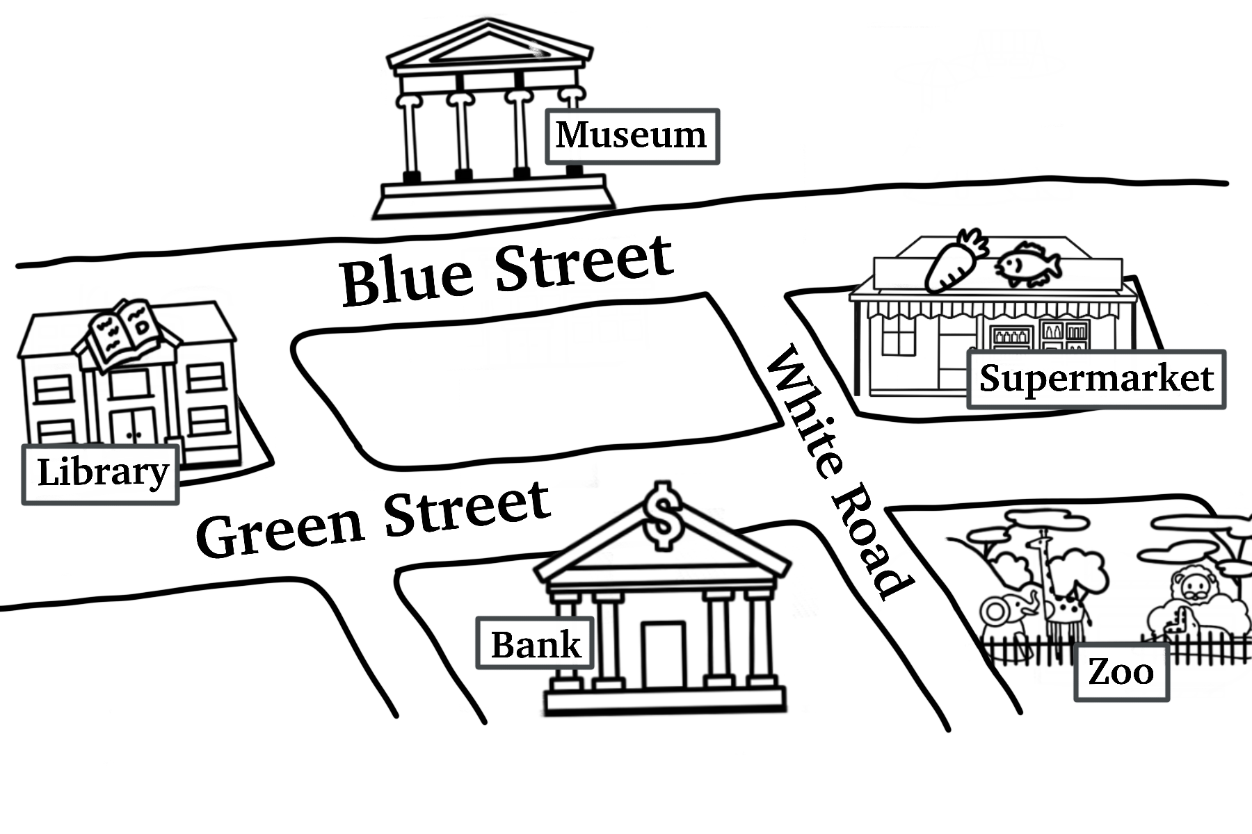
14.
- They are at Taipei Library.
- They are at Taiwan Museum.
- They are at Taipei Zoo.
- They are at Mega Bank.

15.
- She is going to Red Road.
- She is going to Welcome Supermarket.
- She is going to Taiwan Museum.
- Bob is going to Taipei Library.

各位同學，聽力能力檢測已經完成了，下一大題開始為閱讀能力檢測。
現在請翻到下一頁繼續完成作答。
第二部分：閱讀能力檢測
【說明】
請依單字或圖片選出相對應的答案，並將其號碼塗在答案卡上，共20小題。
【例題】

看到題目：

看到選項：
① read ② write ③ dance ④ sing

選出正確答案：①

現在請開始作答。

16. kitchen
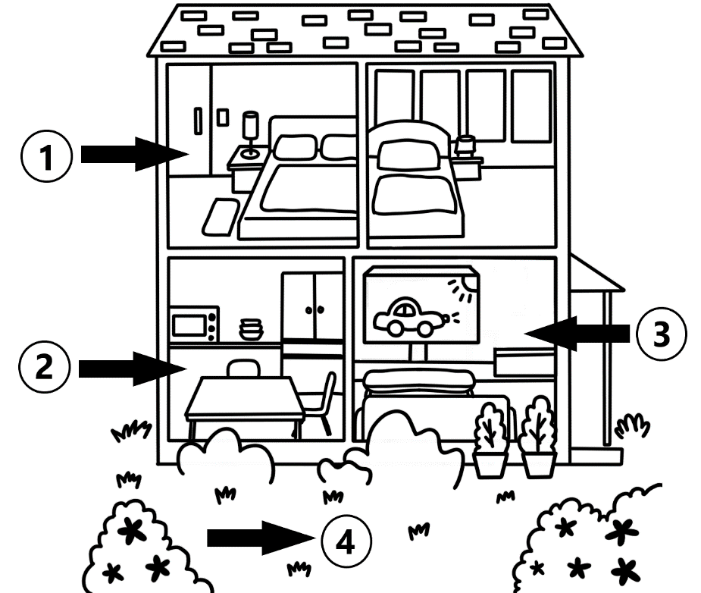
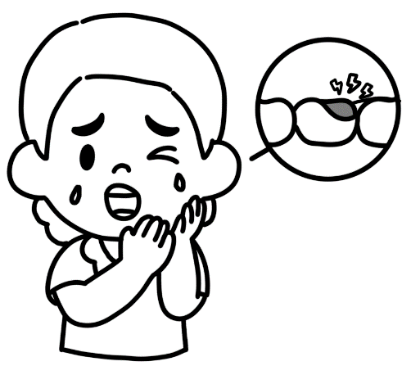
17.
- cold
- stomachache
- headache
- toothache


18.
- a beautiful dress
- a beautiful scarf
- a nice jacket
- a nice vest

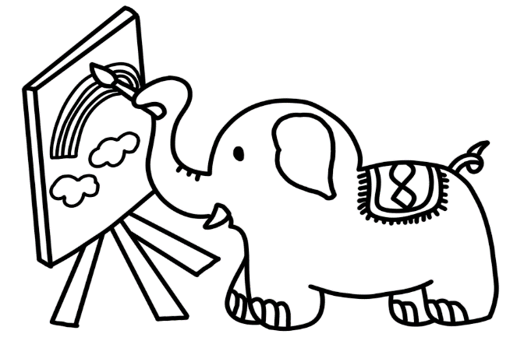
19.
- The bird can sing.
- The lion can dance.
- The elephant can draw.
- The bear can ride a bike.

20. There are ______.
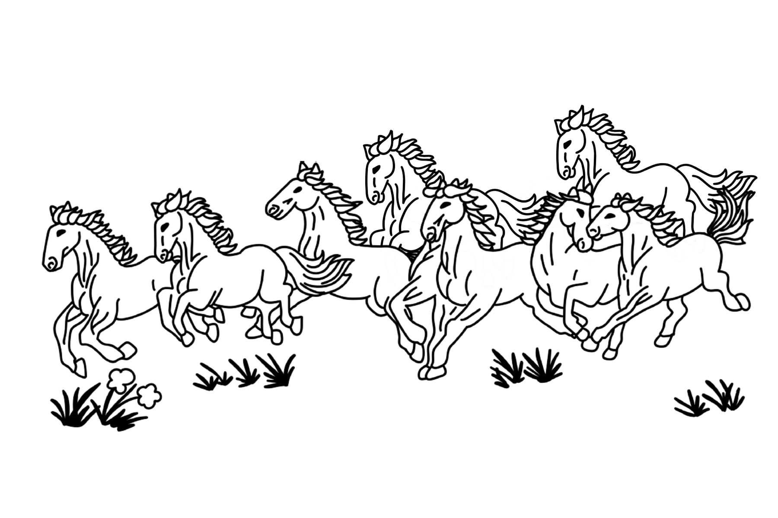
- a horse
- eighty turtles
- eighteen zebras
- eight horses

21. Wash your hands.
 | ① | ②
 | 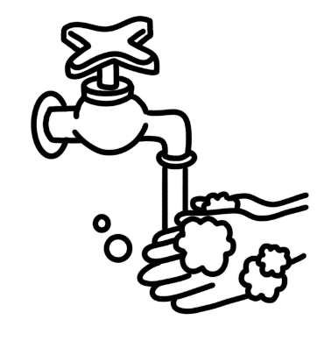 | 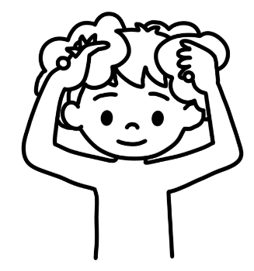
 | ③ | ④
 |  | 

22. Circle the word “cat”.

 | ① | ②
 | 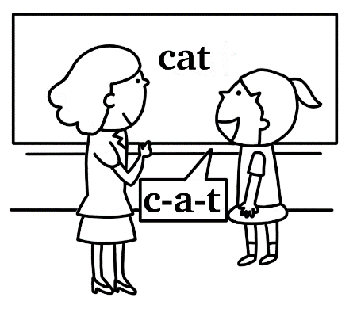 | 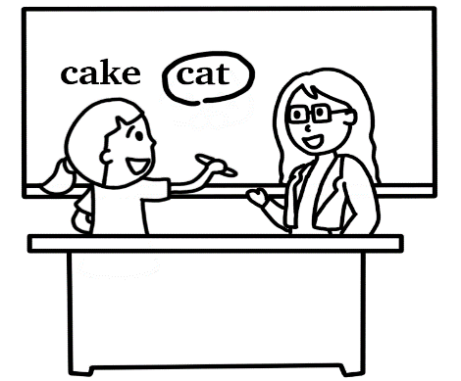
 | ③ | ④
 | 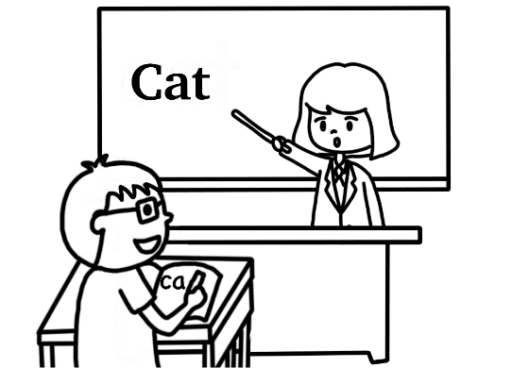 | 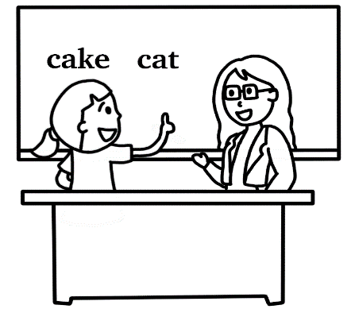

23. This is Will’s weekly plan. Which is true?
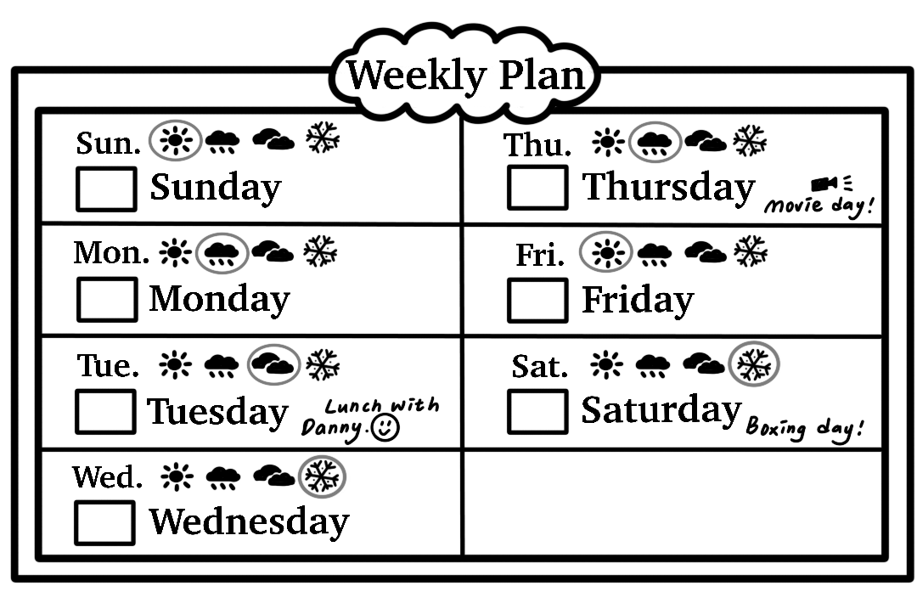
- It’s cloudy on Monday.
- It’s sunny on Friday.
- It’s hot on Wednesday.
- It’s rainy on Saturday.

24. Jane was born(出生) in 2017. It’s 2024 now. How old is Jane?
- She is seventeen years old.
- She is eleven years old.
- She is seven years old.
- She is five years old.

25. Jay’s friends show their feelings for his post (貼文). Which is true?
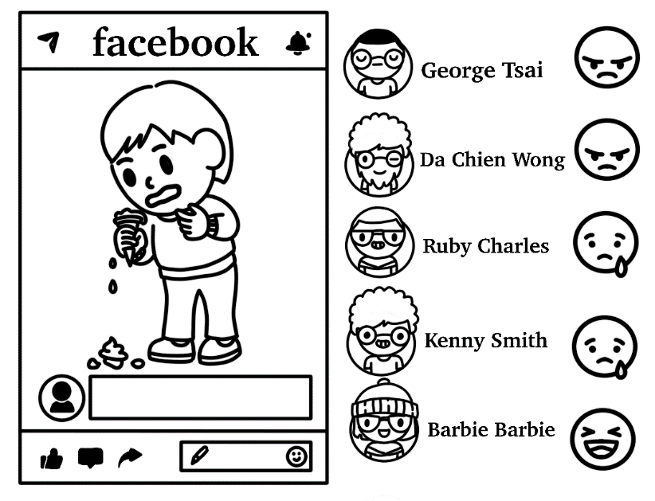
- George is happy.
- Three of Jay’s friends are angry.
- Two of Jay’s friends are happy.
- Ruby is sad.

26. Which is true?
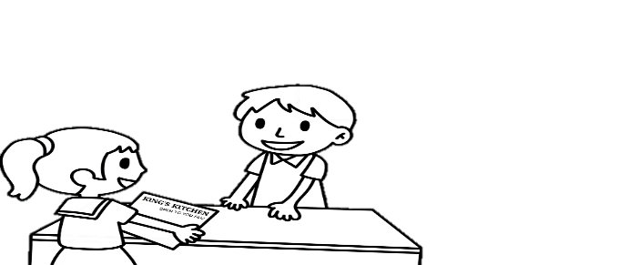
- The hamburger is forty dollars.
- The hot dog is forty-five dollars.
- The girl wants some milk and juice.
- The girl wants a hot dog, some noodles and some juice.
27. The cook is short and heavy.
 | ① | ②
 |  | 
 | ③ | ④
 | 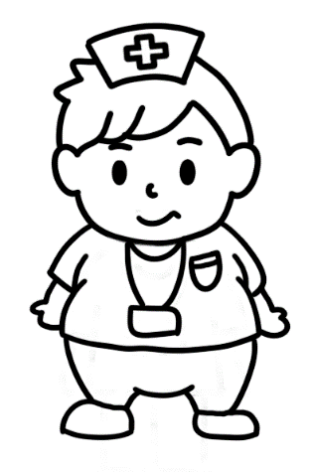 | 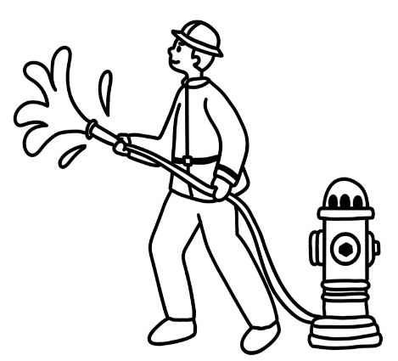

28. Hank doesn’t have a pencil.
He says: “Lily, may I borrow your pencil?”
 | ① | ②
 | 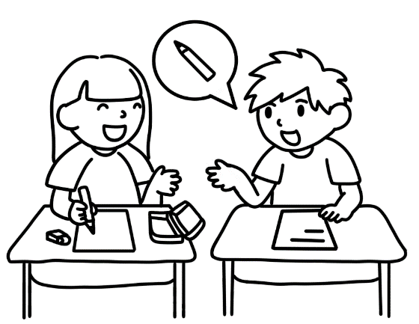 | 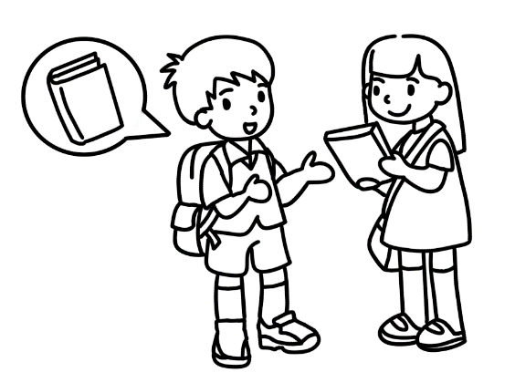
 | ③ | ④
 | 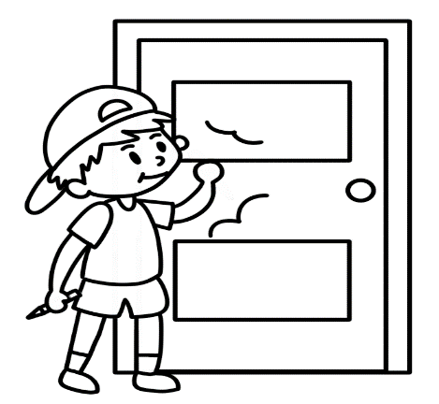 | 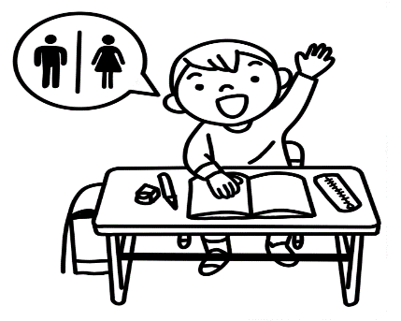

29.
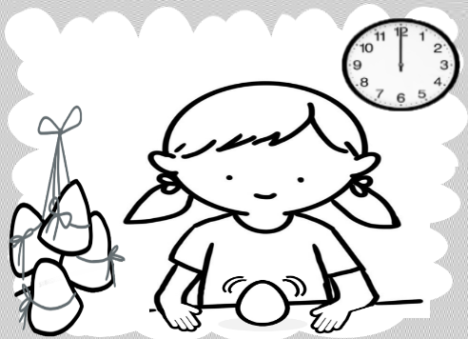
- We get lucky money on Chinese New Year’s Eve.
- We paint pomelo hats on Moon Festival.
- We sing Christmas songs on Christmas.
- We stand eggs on Dragon Boat Festival.

30.
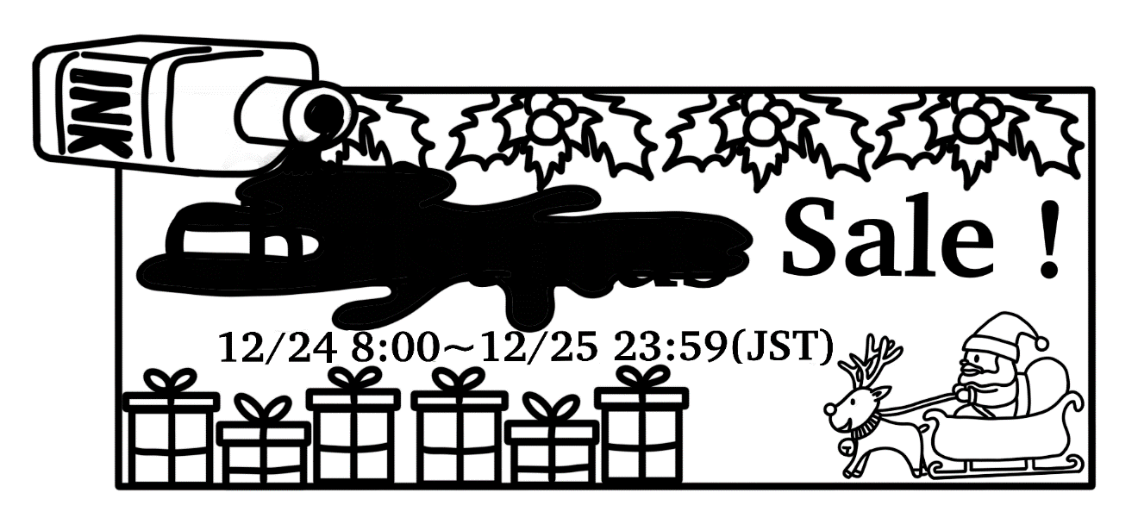
- Christmas
- Easter
- Halloween
- New Year

◆31-32
Student Emergency Contact Card (緊急連絡卡)
Name: Harry Yang | School Name: Sunny Elementary School
Birthday: 2012.6.19 | Class: 6-A
Phone Number: 0934-567890 | Teacher: Sharon Pong
Contact (聯絡人) 1: | Contact 2:
Name: Mandy Lin | Name: Nick Yang
Birthday: 1985.10.04 | Birthday: 2002.3.30
Phone Number: 0912-345678 | Phone Number: 0987-654321
Relation: Harry’s mother | Relation: Harry’s brother
Job: Doctor | Job: Police Officer
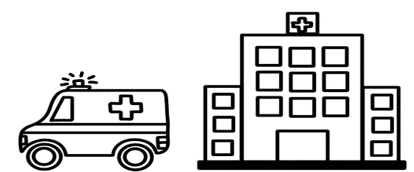
31. Teacher Sharon has to call Harry’s mother. The number is _______.
- 0934-567890
- 0912-345678
- 0987-654321
- 1985-1004

32. Which is true?
- Nick is eleven years old.
- Harry is a student.
- Sharon is a doctor.
- Mandy is Nick’s sister.

◆33-35
Welcome to the Art Museum. This is our ticket price list (票價表).
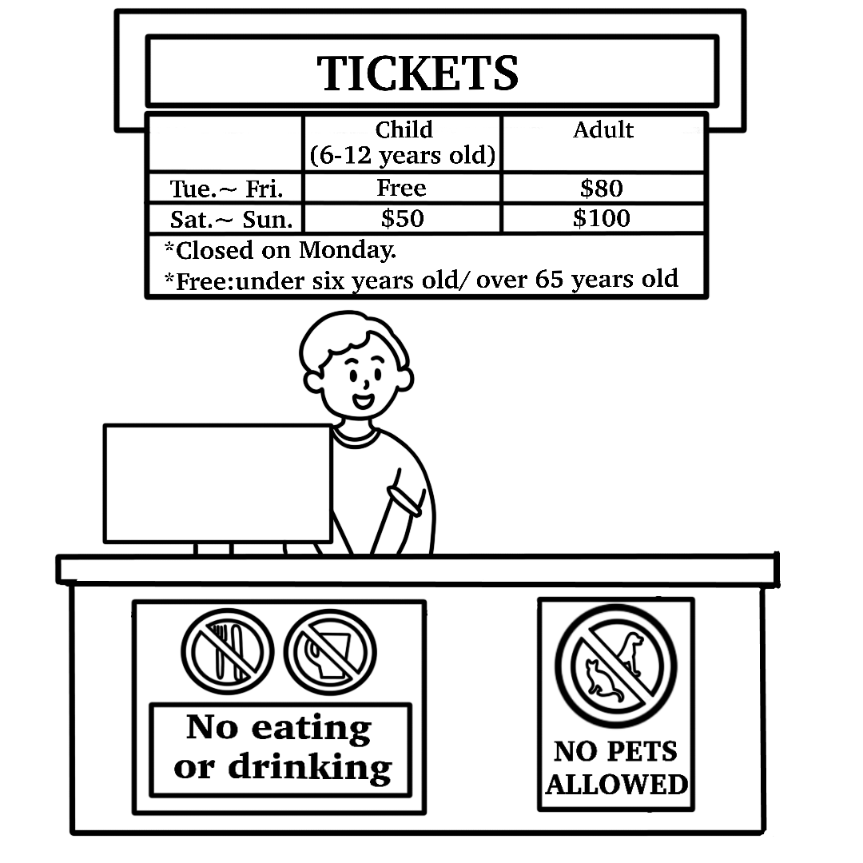

33. Windy goes to the Art Museum, but it’s not open. What day is it?
- It’s Sunday.
- It’s Monday.
- It’s Tuesday.
- It’s Wednesday.

34. Jerry is 9 years old. Jerry’s mom is 40 years old.
They go to the Art Museum.
Their tickets are one hundred and fifty dollars.
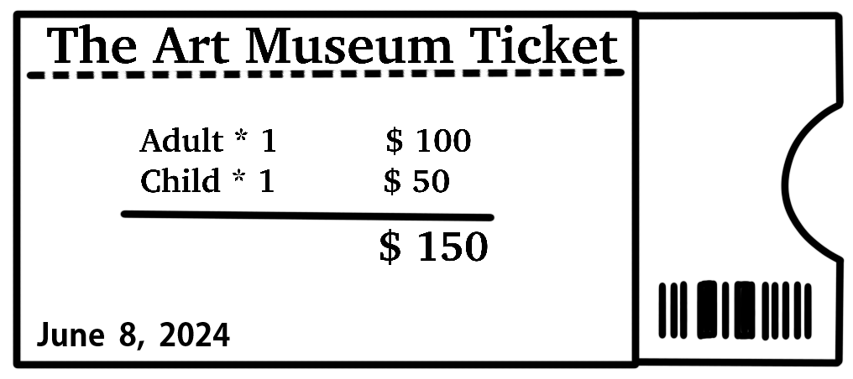What day is it?
- It’s Wednesday.
- It’s Thursday.
- It’s Friday.
- It’s Saturday.

35. What can we do in the museum?
- We can eat hamburgers.
- We can drink soda.
- We can walk the dog.
- We can see paintings.

