114年學力檢測測驗題本
英語文五年級
作答注意事項：
各位同學：
你們好。
這是一份英語文的試題，總共35題。
第一個部分是15題聽力測驗，
第二個部分是20題閱讀測驗。
測驗時間為40分鐘。
每一題請選出一個最合適的答案，並用2B鉛筆在答案卡畫記，不可超出格線外，如果需要修改答案，請使用橡皮擦擦拭乾淨，再重新畫記。
畫記說明：
當你想選④時，請在「答案卡」該題題號後方把④的圓圈塗黑，如：① ② ③ ●
其他事項：
- 每一題都要回答。
- 試題如有錯誤，請立即告知老師。

學 校
班 級
座 號
姓 名
114年學力檢測題本
英語文五年級聽力及閱讀測驗

各位同學，我們將要進行英語的聽力及閱讀測驗。

第一部分是聽力測驗，每一大題都會先說明作答方式，請注意試題本上的例題，播音說明完才會開始播放考試題目。每題會播放兩次，題目不在試題本上，請依照聽到的內容，從各題的四個選項中，選出一個正確或最佳的答案，並畫記在答案卡上。

播音唸下一題題號時，請跟著進行下一題的作答，播音會帶著你做完所有的聽力題目。開始作答後，監考老師不會回答任何問題。但是如果你感覺身體不舒服，可以舉手向監考老師反應。聽力測驗播音完畢時，請自行完成第二部分閱讀測驗。

現在請翻頁。
聽力測驗即將開始，請安靜並專心作答。

第一部分：聽力測驗，共15小題。
【作答說明】
請依據所聽到的辭彙、句子和敘述，選出最適當或相關的答案，將答案的號碼塗在答案卡上，每一題會重複唸兩次。

【例題】
聽到單字：rabbits, rabbits
看到選項：① snakes ② dogs ③ cats ④ rabbits
選出正確答案：④

現在開始播放試題。
 | ① cheer | ② there | ③ share | ④ where
 | ① drink | ② Derek | ③ trick | ④ truck

3. | ① | ② | ③ | ④
 | 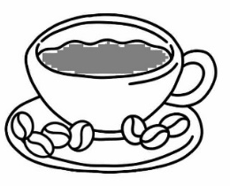 | 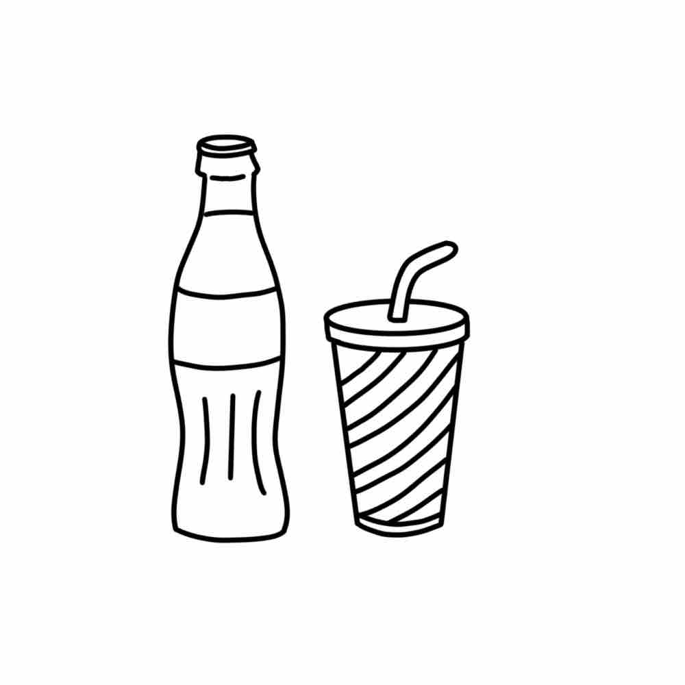 | 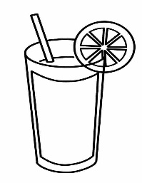 | 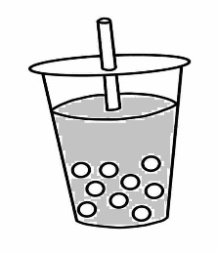

4. | ① | ② | ③ | ④
 |  |  | 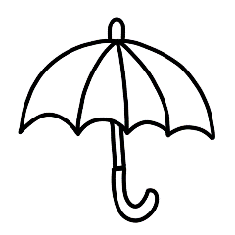 | 

5.
- National Library of Social Studies
- National Museum of Natural Science
- National Math High School
- Chinese and English Resource Center

6. | ① | ② | ③ | ④
 |  | 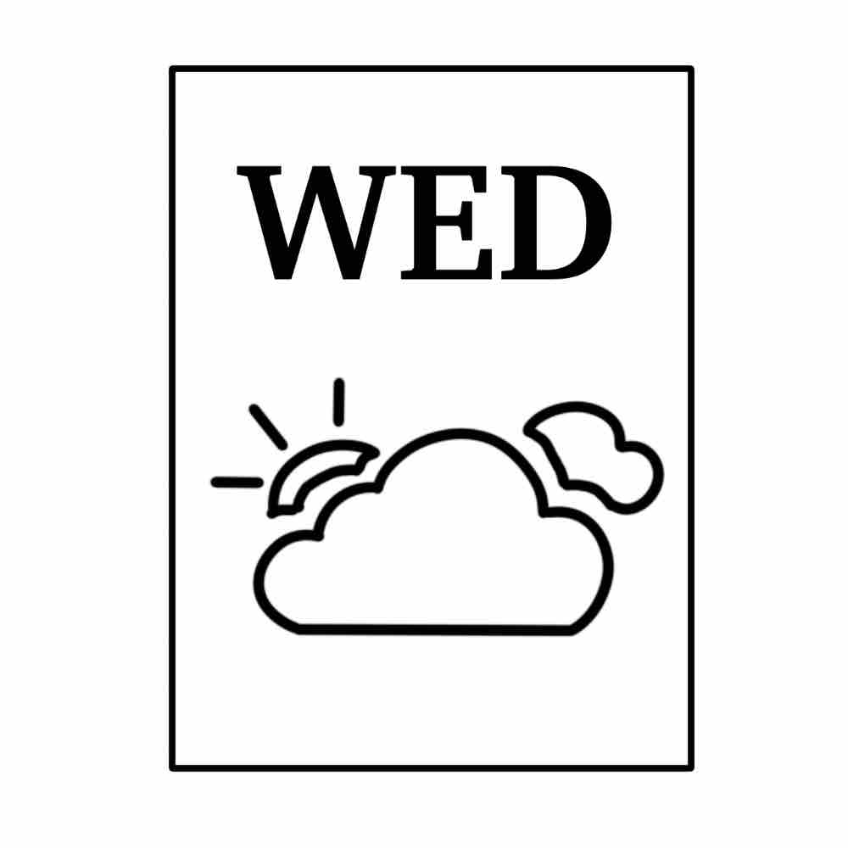 |  | 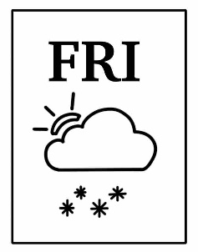

7. | ① | ②
 | 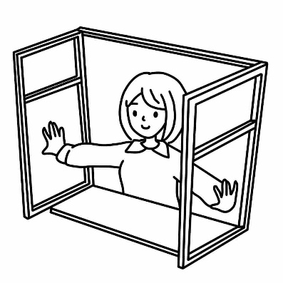 | 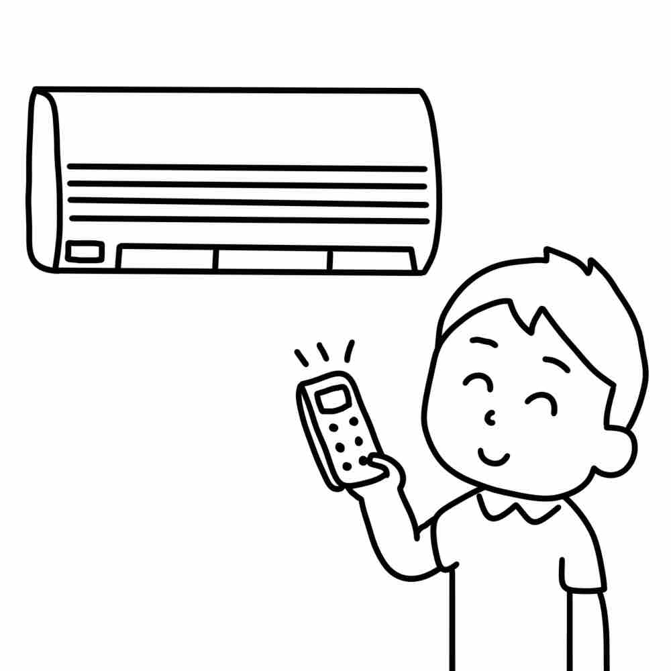
 | ③ | ④
 | 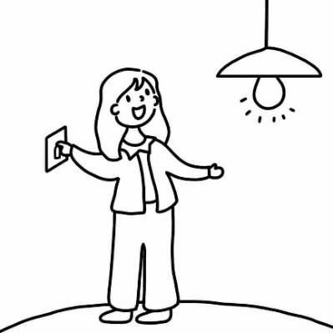 | 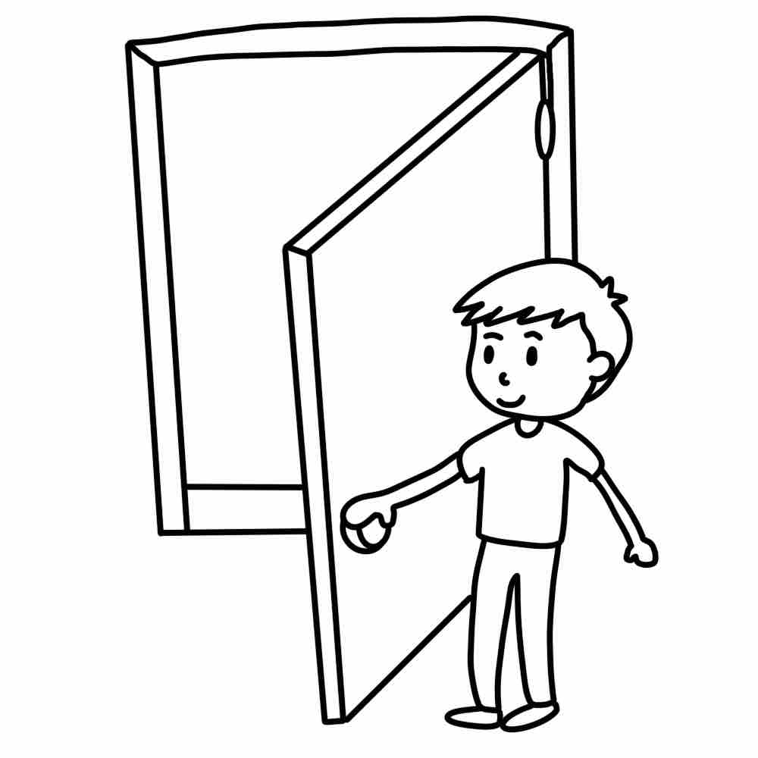

8.
- He’s doing great.
- He’s reading a book.
- He’s a firefighter.
- He’s eight years old.

9. | ① | ②
 | 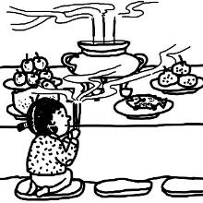 | 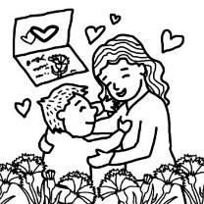
 | ③ | ④
 | 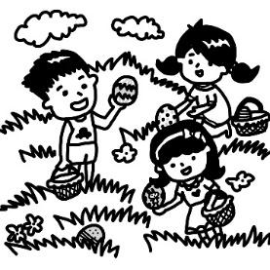 | 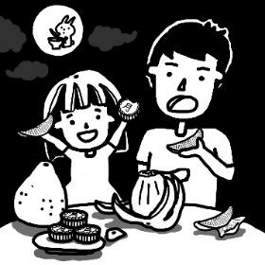

10. | ① | ②
 | 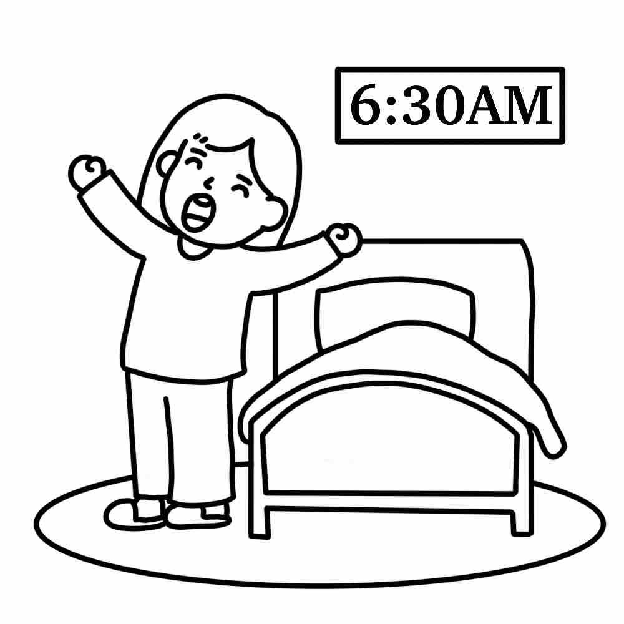 | 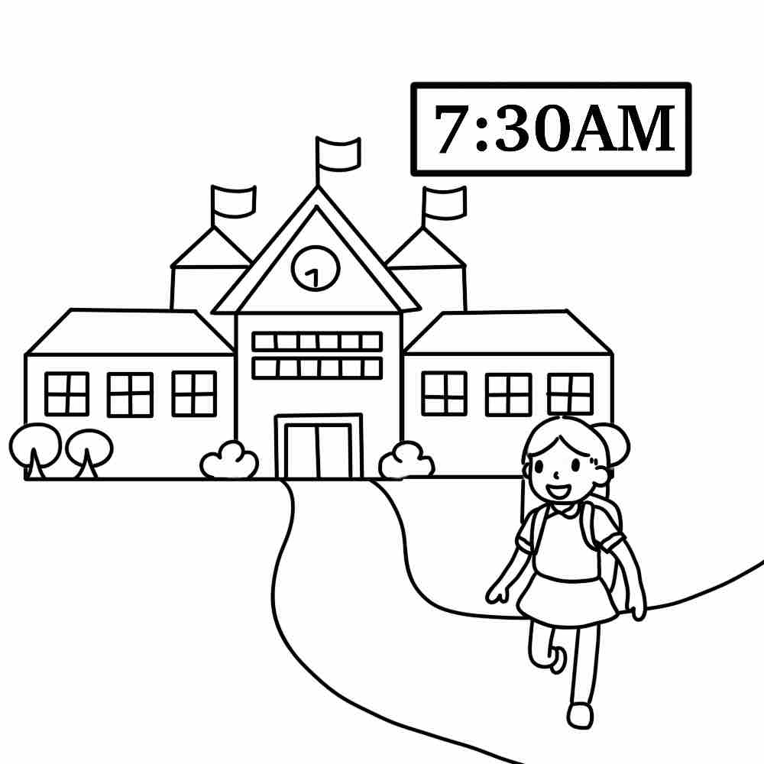
 | ③ | ④
 | 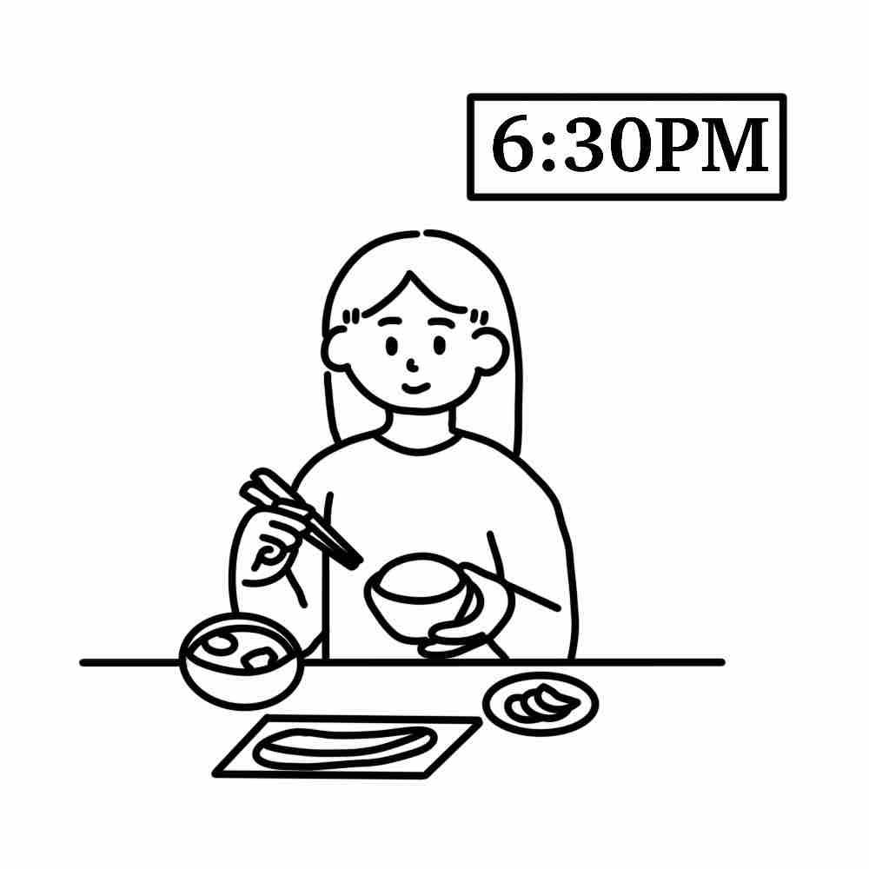 | 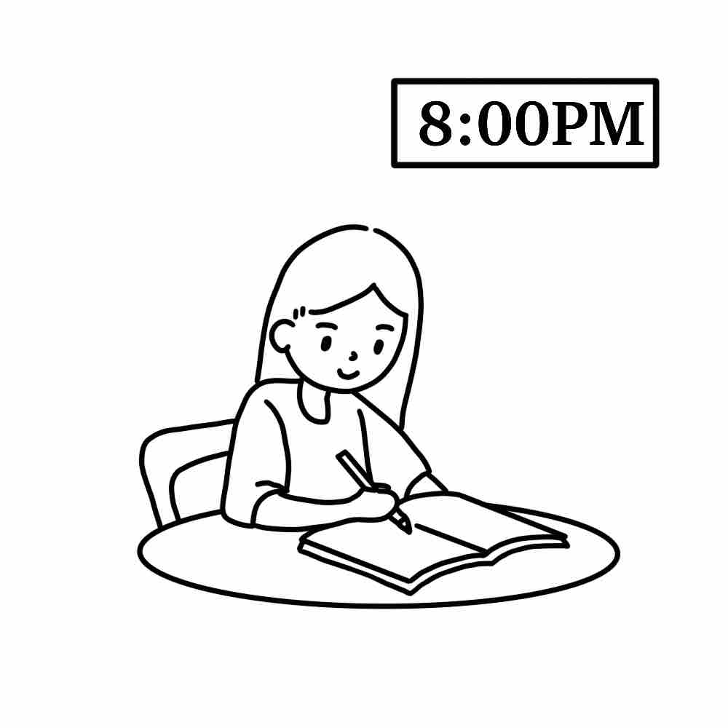

11. | ① | ②
 | 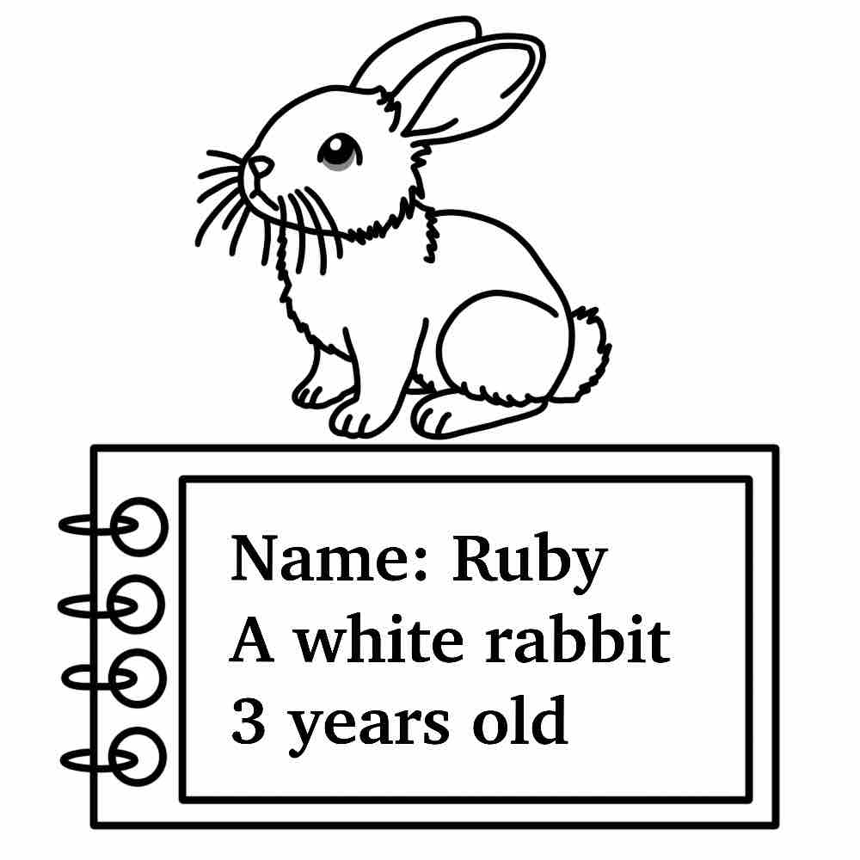 | 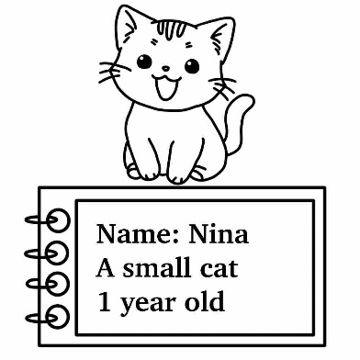
 | ③ | ④
 | 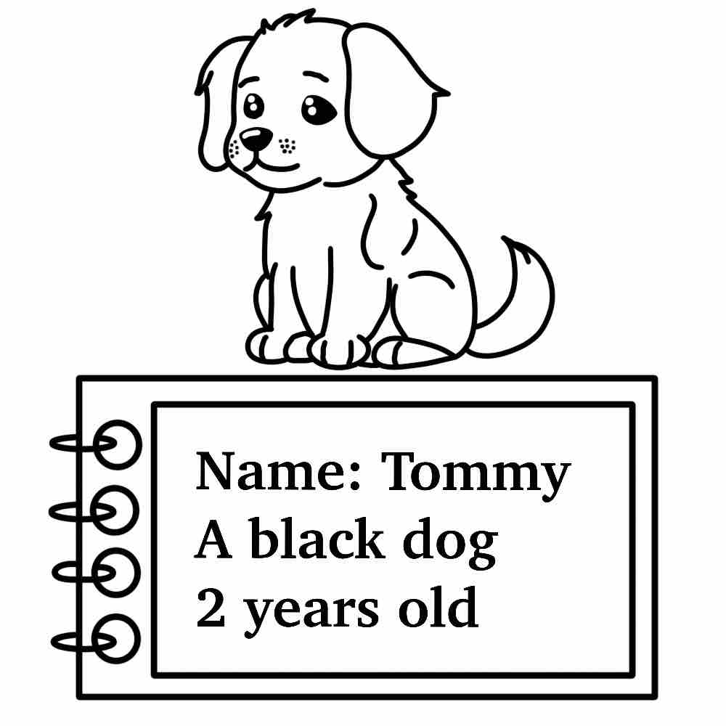 | 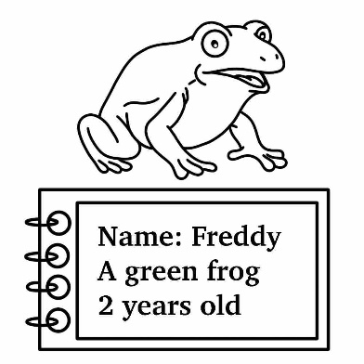
12.
- Thank you very much.
- You are welcome.
- Sorry, I’m late.
- Give me a hand.

13. | ① | ②
 |  | 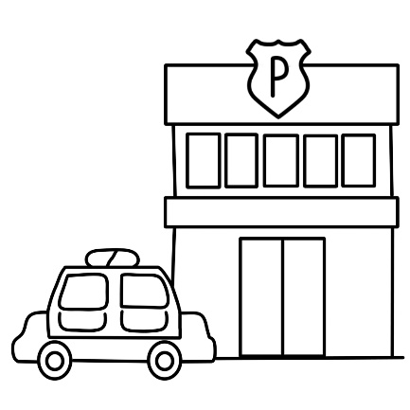
 | ③ | ④
 | 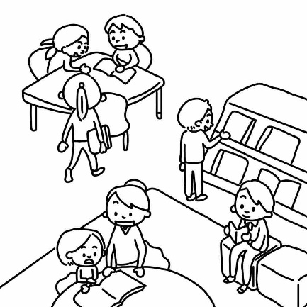 | 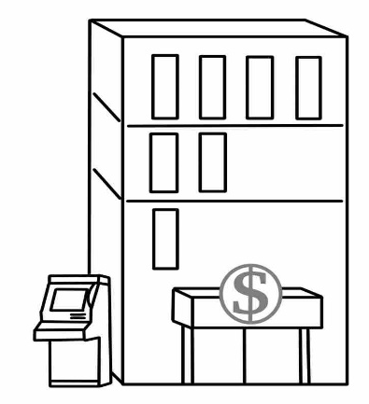

◆14-15
14. | ① | ②
 | 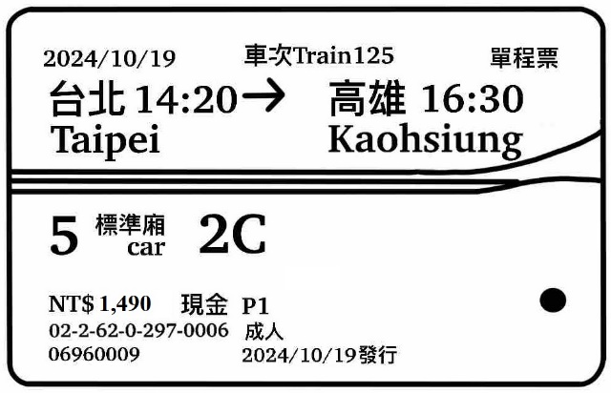 | 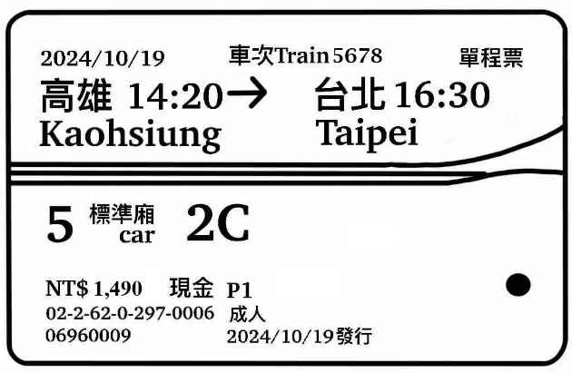
 | ③ | ④
 | 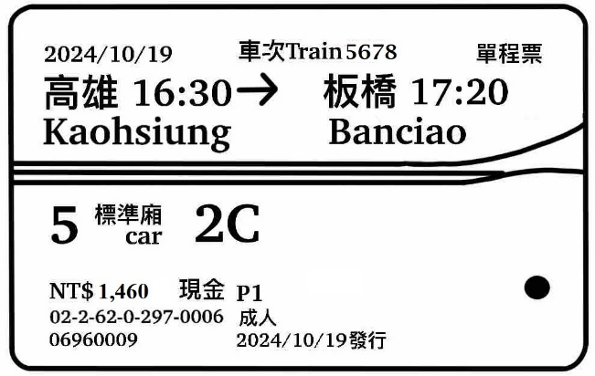 | 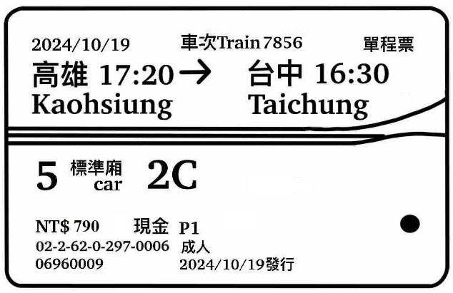

15. | ① | ② | ③ | ④
 |  |  | 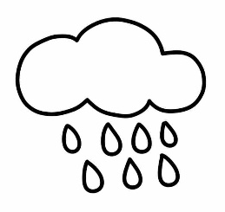 | 

各位同學，聽力試題已播音完畢，下一大題開始為閱讀測驗。
現在請翻到下一頁繼續完成作答。
第二部分：閱讀測驗，共20小題。
【作答說明】
請依單字或圖片選出相對應的答案，並將其號碼塗在答案卡上。
【例題】
看到題目：
看到選項： 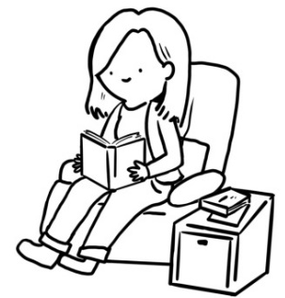
① read ② write ③ dance ④ sing

選出正確答案：①
現在請開始作答。

16.
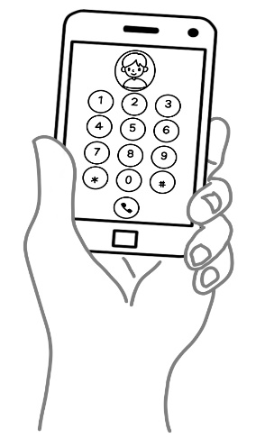

- an umbrella
- a computer
- a sandwich
- a smartphone

17. Today is September 28th. Happy __________________ Day!
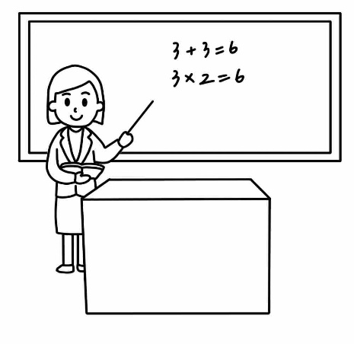
- Student’s
- Teacher’s
- Doctor’s
- Nurse’s

18. Touch your nose.
① | ②
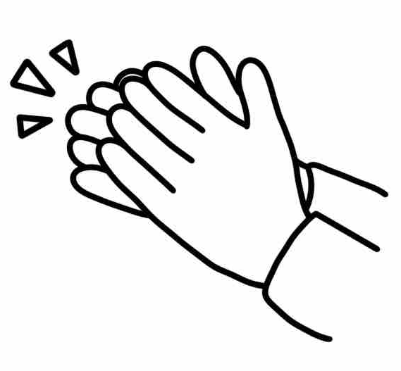 | 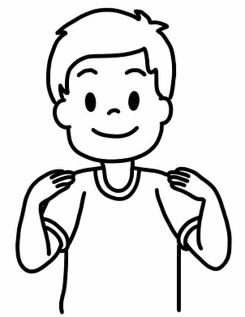
③ | ④
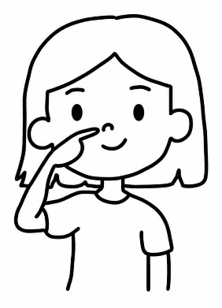 | 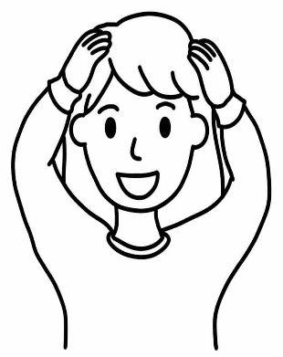

19.
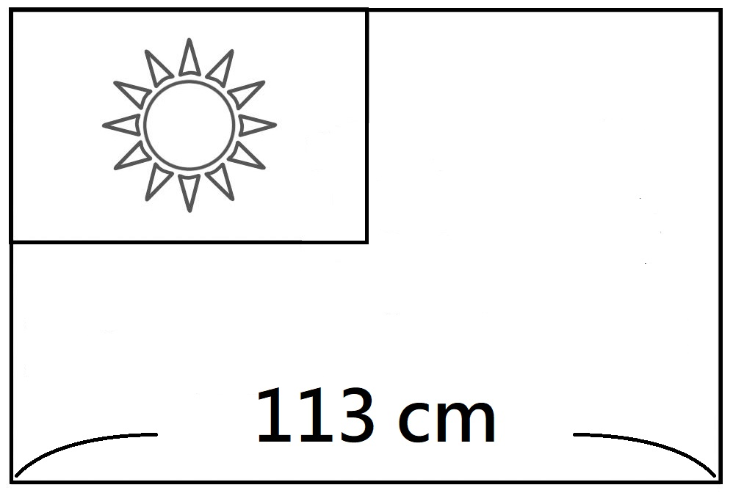

- It’s one hundred and thirteen centimeters (公分) long.
- It’s one hundred and thirty centimeters (公分) long.
- It’s eleven centimeters (公分) long.
- It’s three centimeters (公分) long.

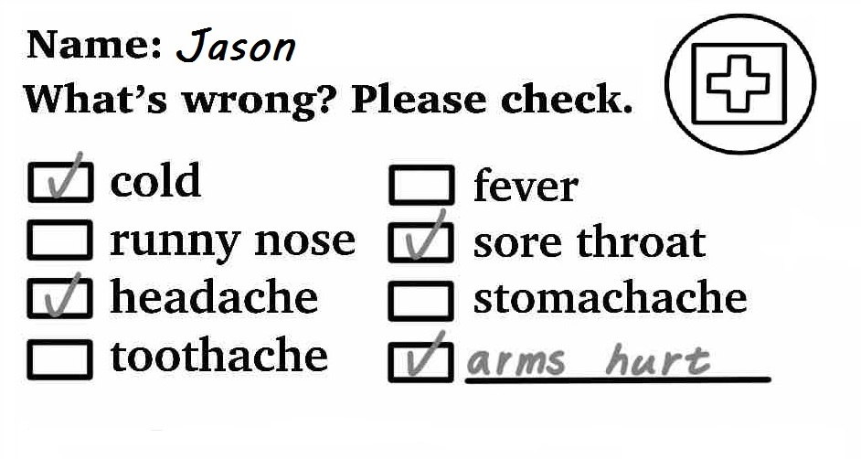20. Which (哪一個) is true?

- Jason is in the hospital.
- Jason’s feet hurt (痛).
- Jason doesn’t have a cold.
- Jason has a stomachache.

21.
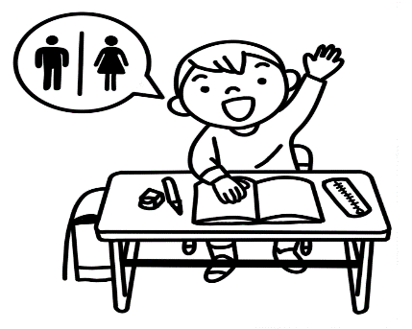

- May I go to the restaurant?
- May I go to the restroom?
- May I open the window?
- May I come in?

22. The library is closed. What time is it?
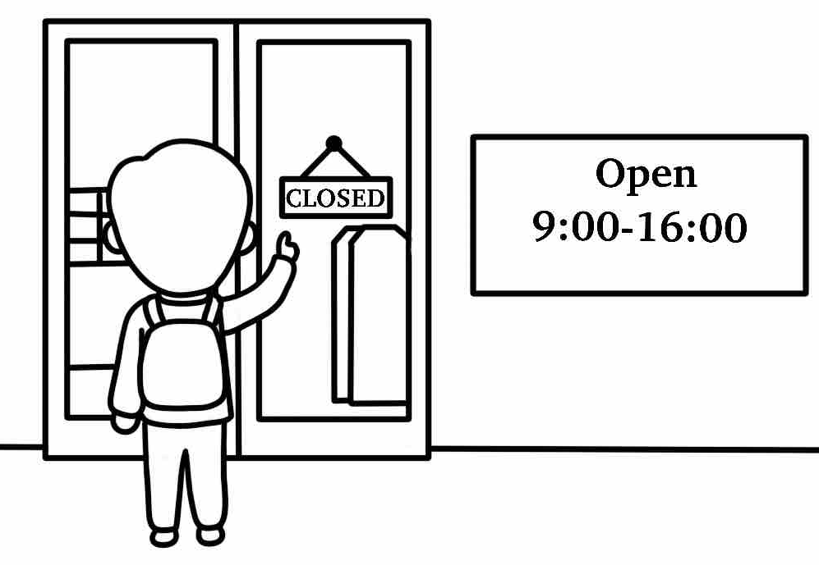
- It’s two o’clock in the afternoon.
- It’s ten thirty in the morning.
- It’s eight o’clock in the morning.
- It’s three thirty in the afternoon.

23. Jack is at school. It’s 9 o’clock. He is playing basketball.
At 9:30, he is going to the science class. What day is today?
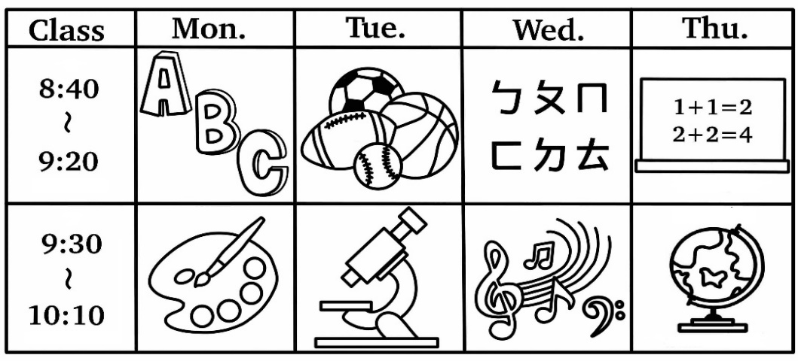
- It’s Monday.
- It’s Tuesday.
- It’s Wednesday.
- It’s Thursday.

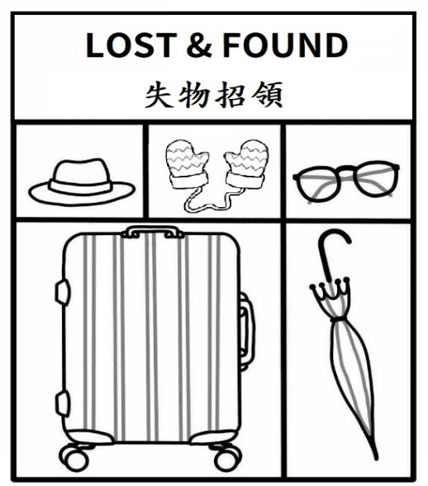
24. Look at the picture, which (哪一個) is true?

- There is a water bottle.
- Teddy’s lunchbox is here.
- We can see it in the bathroom.
- I can’t find my umbrella. I can come here.
25. She is wearing a dress and a scarf.
① | ②
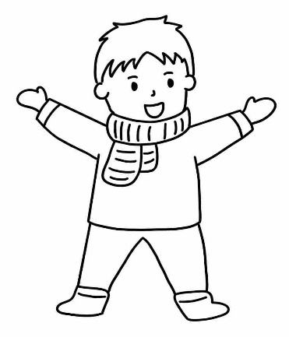 | 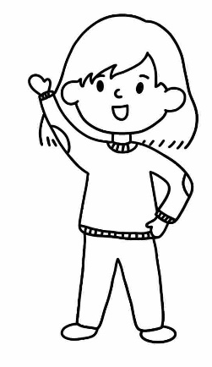
③ | ④
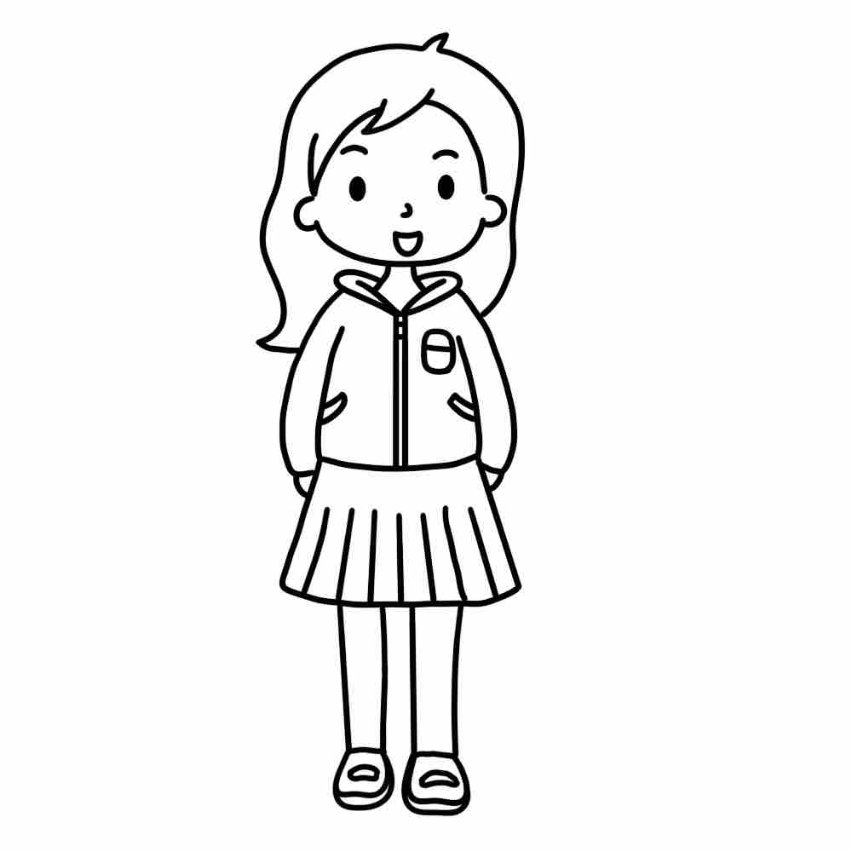 | 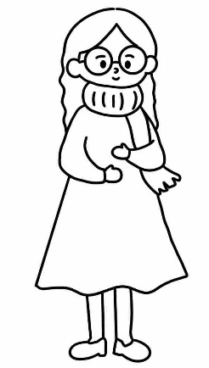

26. Where is he going?
- I’m ten.
- It’s green.
- She goes to bed.
- He is going to the bank.

27. Look at the picture, what is the ?

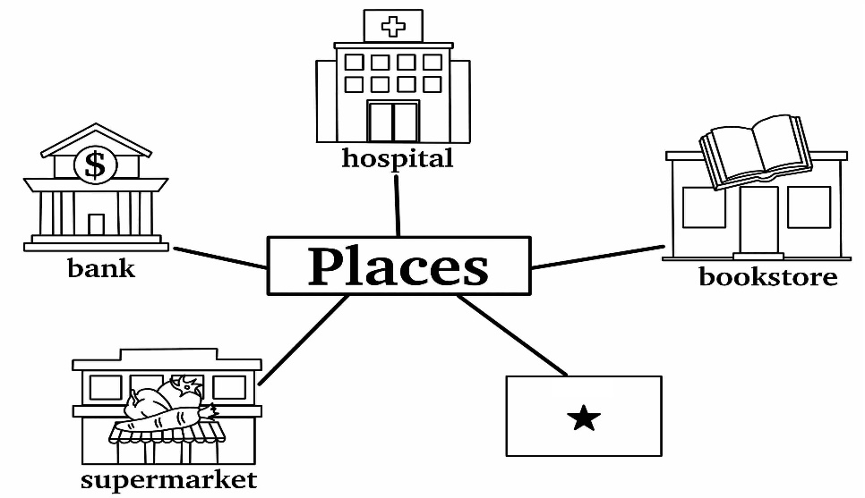

- It’s a marker.
- It’s a hot dog.
- It’s a bakery.
- It’s a panda.

28. What do you see on the Christmas tree?
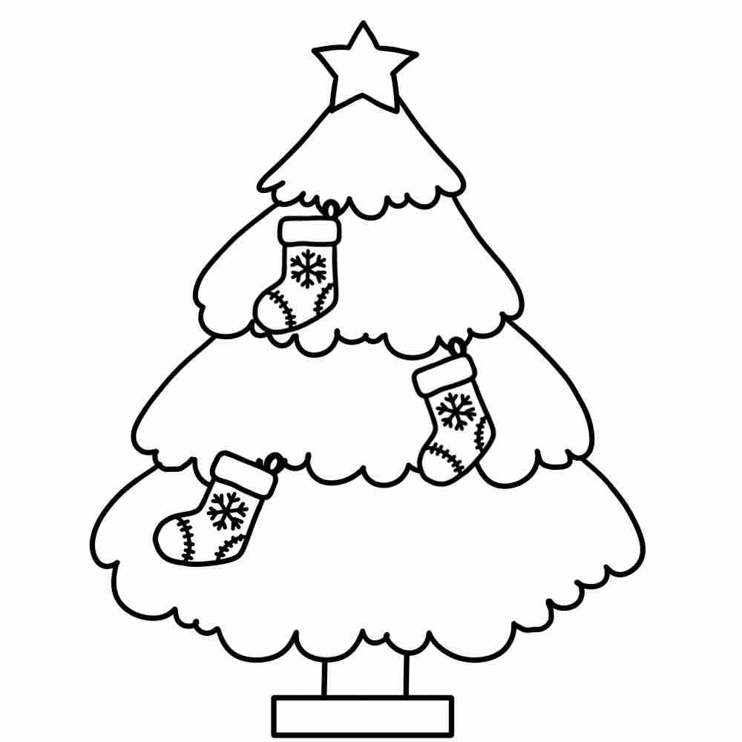
- I see a star and stockings.
- I see Santa and a snowman.
- I see flowers and gifts.
- I see eggs and dragon boats.

29. Jenny is free on Tuesdays and Saturdays.
She can go to ________________________________ events (活動).
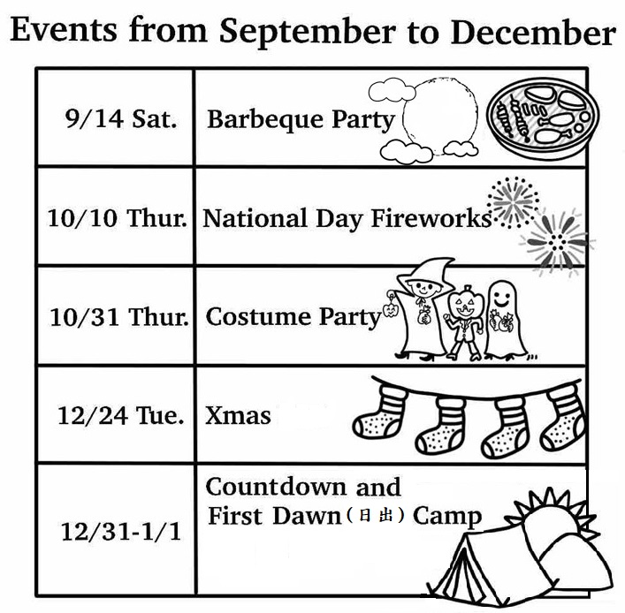

- Moon Festival and Double Tenth Day
- Double Tenth Day and Halloween
- Halloween and New Year
- Moon Festival and Christmas

30. Where is May?
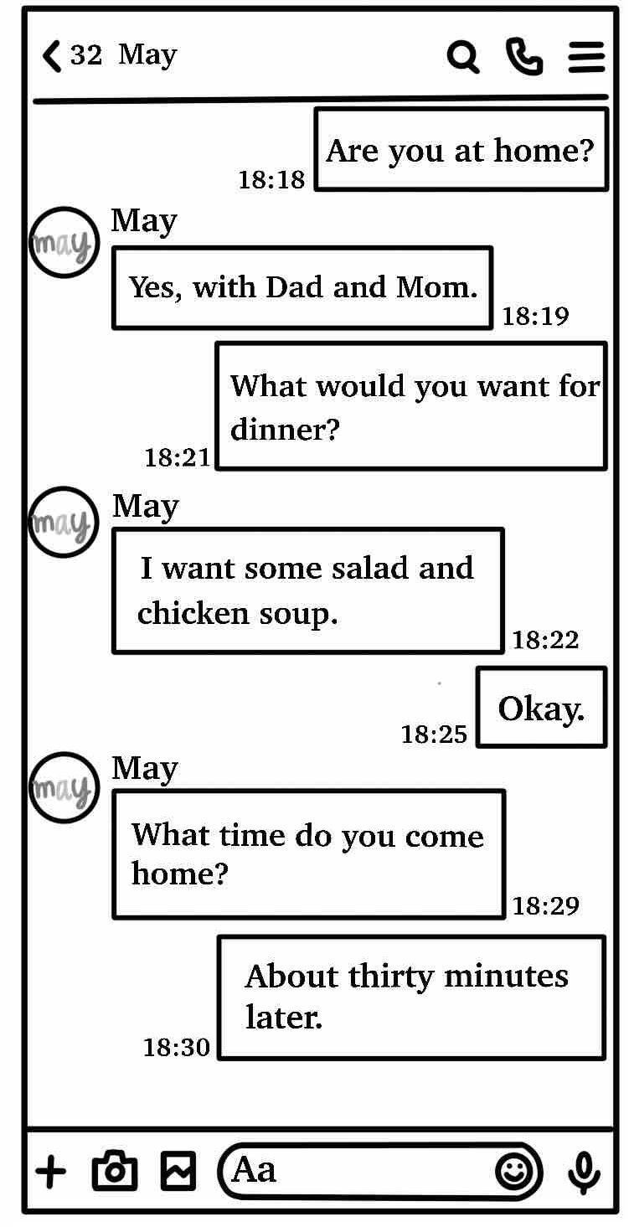

- She is in the supermarket.
- She is in the post office.
- She is at school
- She is at home.

◆31-33
These are Hank, Lisa, and Ivy's plans (計畫) for this Sunday.
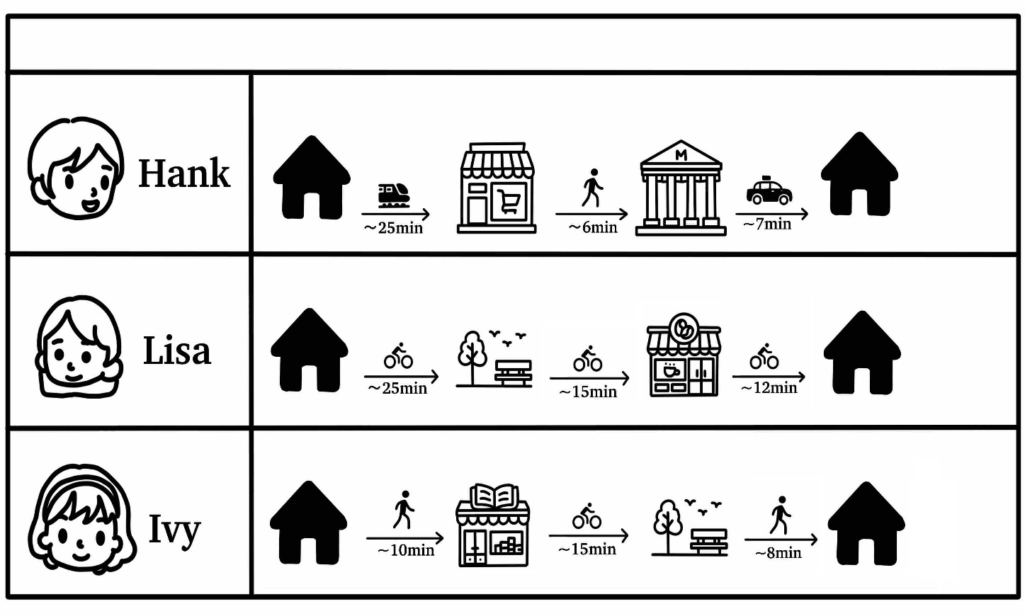

31. Where is Hank going this Sunday?
- He is going to a supermarket.
- He is going to a bookstore.
- He is going to a post office.
- He is going to a hospital.

32. Lisa and Ivy both (兩人都) go to ★, what place is this?
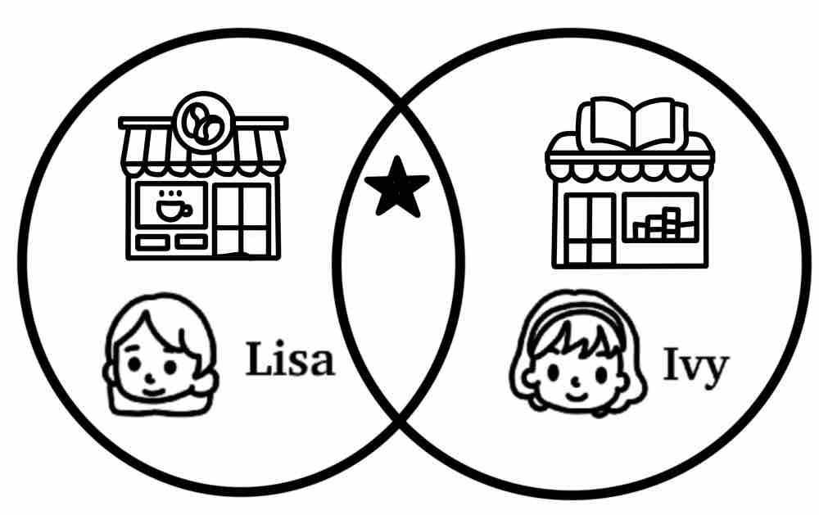

- It’s the bakery.
- It’s the park.
- It’s the bank.
- It’s the museum.

33. How does Lisa go home?
- She goes home by bus.
- She goes home by car.
- She goes home by taxi.
- She goes home by bike.

◆34-35
Jason’s weekly schedule
Monday | 10/7 Bring a basketball
Tuesday | 10/8
Wednesday | 10/9 Bring a swimming suit
Thursday | 10/10 Happy Birthday Day!
Friday | 10/11 Field Trip (戶外教學)!
Saturday | 10/12
Sunday | 10/13

34. What day does Jason have swimming class?
- He has swimming class on Monday.
- He has swimming class on Wednesday.
- He has swimming class on Double Tenth Day.
- He has swimming class on his birthday.

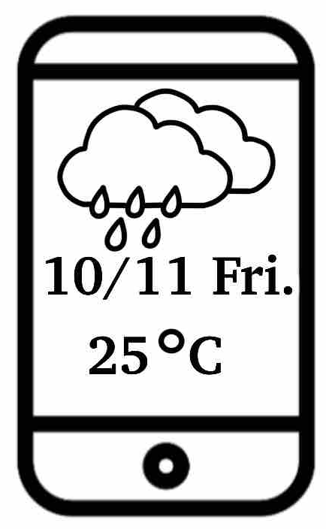
35. Look at the weather on Friday.
What does Jason need in his bag?
- He needs sunglasses.
- He needs an umbrella.
- He doesn’t need his bag.
- He doesn’t need his phone.

