110年學力檢測題本
英語文八年級
作答注意事項：
各位同學：
你們好。
這是一份英語文的試題，總共35題。
第一個部分是15題聽力能力檢測，
第二個部分是20題閱讀能力檢測。
測驗時間為45分鐘。
每一題請選一個最合適的答案，並用2B鉛筆在答案卡畫記，不可超出格線外，如果需要修改答案，請用橡皮擦擦拭乾淨，再重新畫記。
畫記說明：
當你想選擇的答案為②時，正確畫記為 ① ● ③ ④
其他事項：
- 每一題都要回答。
- 試題如有錯誤，請立即告知老師。

學 校
班 級
姓 名
座 號

110年學力檢測題本
英語文八年級聽力及閱讀測驗

各位同學，我們將要進行英語的聽力測驗和閱讀能力測驗。第一部分是聽力測驗共三大題，每一題都會先說明作答方式，請注意試題本上的例題，錄音說明完才會開始播放考試的題目。

每題會播放兩遍，題目不在試題本上，請依照聽到的內容，並看到各題的四個選項中，選出一個正確或最佳的答案，並畫記在答案卡上。錄音唸下一題時，你就要跟著做下一題。錄音會帶著你做完所有的聽力題目。開始作答後，請自行完成測驗，監考老師不會回答任何問題。但是你如果感覺身體不舒服，可以舉手向監考老師反應。

現在請翻頁。聽力測驗即將開始，請安靜並專心作答。

第一部分：聽力能力檢測，共三大題，15小題。
第一大題：辨識句意（第1-3題）
作答說明：請依據所聽到的句子，選出符合描述的選項，每題播放兩次。

示例題：你會看到
 | 
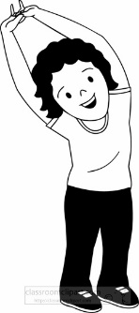 | 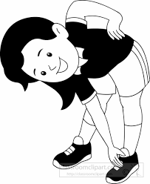

然後你會聽到．．．．．（播音）。依據所播放的內容，正確答案應該選，請將答案卡該題「」的地方塗黑、塗滿：即 ●

① | ② | ③ | ④
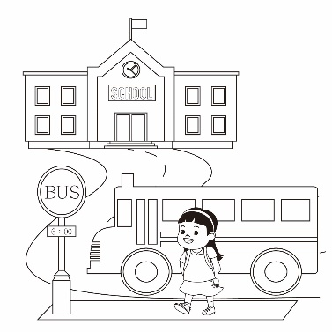 | 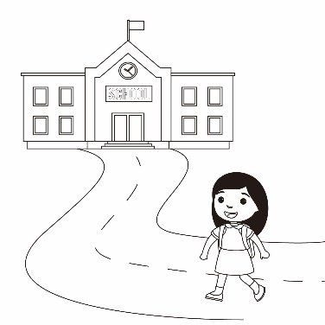 | 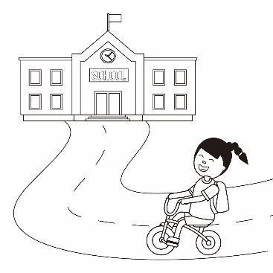 | 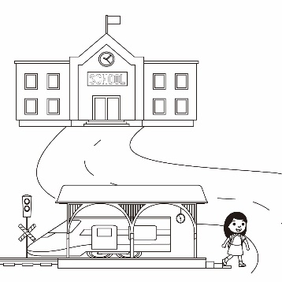

① | ②
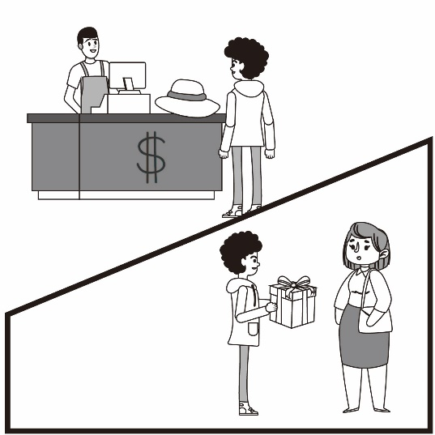 | 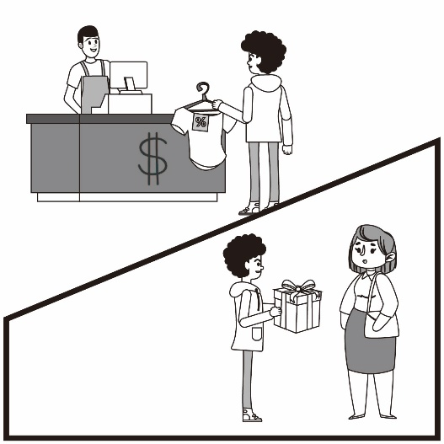
③ | ④
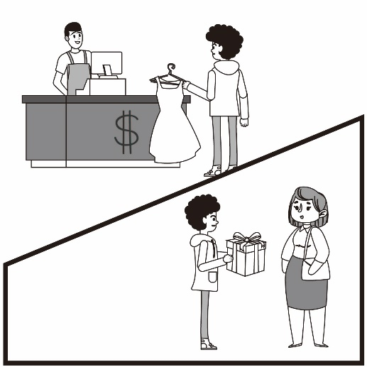 | 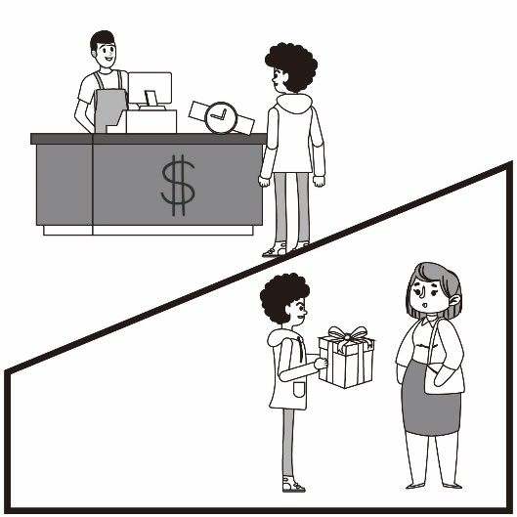

① | ② | ③ | ④
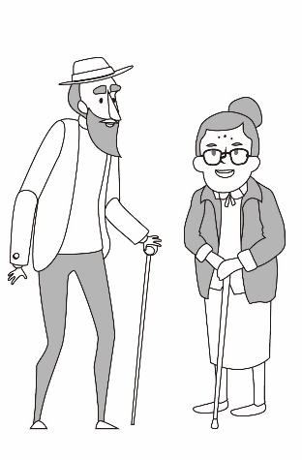 | 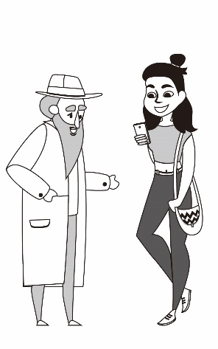 | 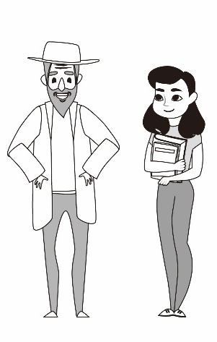 | 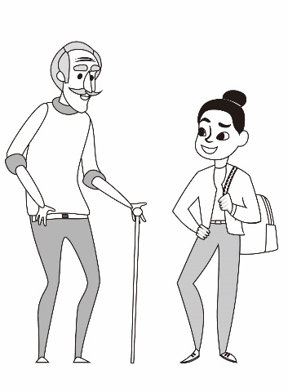

第二大題：基本問答（第4-8題）
作答說明：每題均有四個選項，請依據所聽到的內容，選出一個最適合的回應，每題播放兩次。
示例題：你會看到
① Yes, I am angry.
② No, I am happy.
③ Yes, I want a hamburger.
④ No, this is not a hamburger.

然後你會聽到．．．．．．（播音）。依據所播放的內容，正確答案應該選③，請將答案卡該題「③」的地方塗黑、塗滿：即 ①②●④

  - I live next to the train station.
  - I am waiting for the train.
  - It’s in the train station.
  - It’s just around the corner.

- I didn’t like the music.
- We had a great time.
- My brother and sister.
- Thank you. Good night!

- I can’t wait.
- Have a nice day.
- It takes time.
- That’s too slow.

- I want to sleep now.
- I went to the gym.
- I will go swimming.
- I will go out for dinner.

- It is from Japan.
- It’s light green.
- It’s three thousand NT dollars.
- It takes me two weeks to make it.

第三大題：言談理解（第9-15題）
作答說明：每題均有四個選項，請依據所聽到的對話或短文內容，選出一個最適合的答案，每題播放兩次。
示例題：你會看到
① Thursday.
② Friday.
③ Saturday.
④ Sunday.

然後你會聽到．．．．．．（播音）。依據所播放的內容，正確答案應該選③，請將答案卡該題「③」的地方塗黑、塗滿：即 ①②●④

- At a garden area.
- At a museum.
- At a bookstore.
- At a flower shop.

- In a car.
- On foot.
- By bus.
- By bicycle.

- He is cutting the fruit.
- He cut his finger.
- He can’t find the fruit.
- He can’t find the knife.

- Lisa works in the bookstore.
- Lisa gave her cellphone number to Jack.
- Jack wants to have dinner at the restaurant.
- Jack called the restaurant in the morning.

① | ② | ③ | ④
 |  | 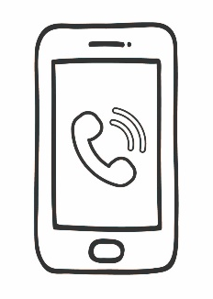 | 

① Doctor.
② Teacher.
③ Actor.
④ Singer.

① At school.
② At a drug store
③ At a supermarket.
④ At a hospital.

各位同學，聽力測驗已經完成了，下一大題開始為閱讀測驗。
現在請翻到下一頁繼續完成作答。

第二部分：閱讀能力檢測，共2大題、20小題。
第一大題：單題（第16-22題）
- Ken: Look! They are flying around the flowers. They are so beautiful!
Mary: Yes. I like the yellow ones.
What are they?
① | Spiders. | ② | Frogs. | ③ | Butterflies. | ④ | Snakes.

- Cindy: Chinese New Year is coming!
Bella: Yes. I can’t wait to see my grandparents and cousins!
Which month is it?
① | August. | ② | February. | ③ | June. | ④ | October.

- Kelly: Dad, can you drive me to the train station?
Mr. Lee: Of course, dear.
How will Kelly go to the train station?
① | By bike. | ② | By bus. | ③ | By train. | ④ | By car.

- Rita: _____ didn’t you come to my birthday party last night?
Ryan: Sorry. My dog was sick, so I took it to the hospital.
① | What | ② | Why | ③ | Where | ④ | When

- Hank: Hey bro, want to play basketball with us?
Humphry: It’s raining now. My dad won’t _____ me go out.
① | let | ② | help | ③ | make | ④ | have

- Judy: Welcome back.
Andy: I didn’t have lunch today. I could eat a horse now.
Judy: Don’t worry. Dinner will be ready soon.
What does “I could eat a horse” mean?
① | Happy. | ② | Angry. | ③ | Sad. | ④ | Hungry.

- Kiki is going to Japan. She checked online and made some notes.
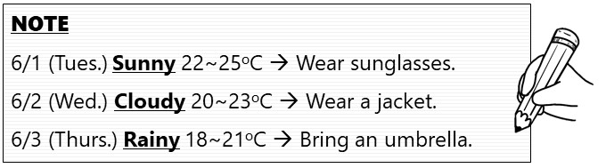
What did Kiki look for online?
① | Weather. | ② | Food. | ③ | Clothes. | ④ | Seasons.
第二部分：題組（第23-35題）
(23-25)
Mia: | John, there is a big sale in the department store.  Let’s buy some new clothes for Christmas.
John: | But 23
Mia: | I don’t think so. Women never have enough clothes.
(In the department store)
Mia: | Look at this dress! Isn’t it beautiful on me?
John: | Yeah, yeah, yeah. Good.
Mia: | How about this jacket? I know I look good in black.
John: | Hmm…yeah. But you have two at home.
Mia: | And this red skirt! Oh, it is so cute.
John: | Wait. 24  The dress, the jacket and the skirt?
Mia: | Yes.
John: | Are you crazy? They are expensive!
Mia: | Looking stylish costs a lot.  25 , right honey?
John: | No way. Use YOUR own money.  stylish時髦的 own自己的

① we have enough clothes.
② the department store is far away.
③ Chinese New Year is in next month.
④ I don’t like to buy clothes.

① It doesn’t look good.
② Are you going to buy all of them?
③ Are you going to give them back?
④ I cannot answer your question.

① I don’t have much time
② I save a lot of money
③ You will pay for them
④ You don’t know me

(26-28)
BBC News January 8th, 2021
The 37th Harbin Ice and Snow Sculpture Festival in China is open to visitors now. It will end on 25 February 2021. The festival is one of the biggest of its kind. The festival began in 1963 and is famous for big ice and snow sculptures. People also enjoy activities like ice football and skiing there. Because of COVID-19, foreign tourists cannot visit China, so most of the visitors are people from other parts of China.
In December every year, about 300 farmers and house builders become "ice miners" to make the festival's big ice sculptures. To build the ice structures, they cut tens of thousands of ice blocks from the river and move them to the festival park. The workers then make ice houses and sculptures there, and some of them are bigger than real houses. Why do they use ice from the river? "Man-made ice isn't that thick, and it isn't strong enough to stand in the wind," said a worker. "We come to mine ice at 6 a.m. every day," Zhang Wei said. "Sometimes we end our work after 11 p.m." Because of their hard work, people around the world can enjoy looking at the great ice sculptures and watch beautiful light shows at night.
Harbin哈爾濱 sculpture雕塑 man-made人造的 thick厚的
- What does mine mean?
- Eat.
- Sell.
- Grow.
- Cut.

- What is the order of the points in the article? order順序
a. How do they make the ice sculptures?
b. Who will visit the festival?
c. Who makes the ice sculptures?
d. What is the festival famous for?
① d b c a
② c b d a
③ a d c b
④ b c d a

- Which is true?
① The ice houses are smaller than real ones.
② The workers always get off work before 6 p.m.
③ Man-made ice is very thick and strong.
④ People enjoy ice football and light shows there.

(29-32)
Dear Uncle Sam, May, 19th 2021
How are you and Aunt Cindy? It is May now. Is it warm in New York?
We live in Kaohsiung, Taiwan now. Dad teaches English in a junior high school, and Mom makes delicious fruit cakes in her bakery. Our new house is near my school. It is usually sunny and warm in Kaohsiung, so I walk to school every day. Dad only has to drive me to school when it rains.
Uncle Sam, guess what? I have a new pet cat Cherry! We found her near Mom’s bakery a week ago. She was very sick then, so we took her home. Now, she is healthy and pretty, and we play together every day.
It is my first time to have a pet. What can I do for her? You helped so many animals in New York. Could you give me some advice? I give her cat food three times a day. Hope to see you soon.
Best wishes,
Laura
advice建議
- When did Laura find Cherry?
① | May 19th. | ② | May 18th. | ③ | May 12th. | ④ | May 16th.

- How often does Laura’s father drive her to school?
① | Always | ② | Sometimes | ③ | Seldom | ④ | Never

- Here is Uncle Sam’s advice to Laura. What can Laura do for Cherry? litter box廁所
① Feed Cherry milk.
1. Feed Cherry twice a day.
2. Give Cherry water every four hours.
3. Wash Cherry every three weeks.
4. Play with Cherry every day.
5. Cherry cannot have chocolate, milk, or nuts.
6. Don’t put her litter box next to her food bowl.
② Wash Cherry every month.
③ Put Cherry’s litter box by her food.
④ Give Cherry water six times a day.

- Which is true?
① Cherry is a baby dog.
② Cherry is Laura’s first pet.
③ Laura’s mother is a teacher.
④ Cindy and Laura are sisters.

(33-35)
Wally is an English teacher in Seattle Junior High School. Here is a map of his town.
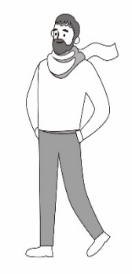
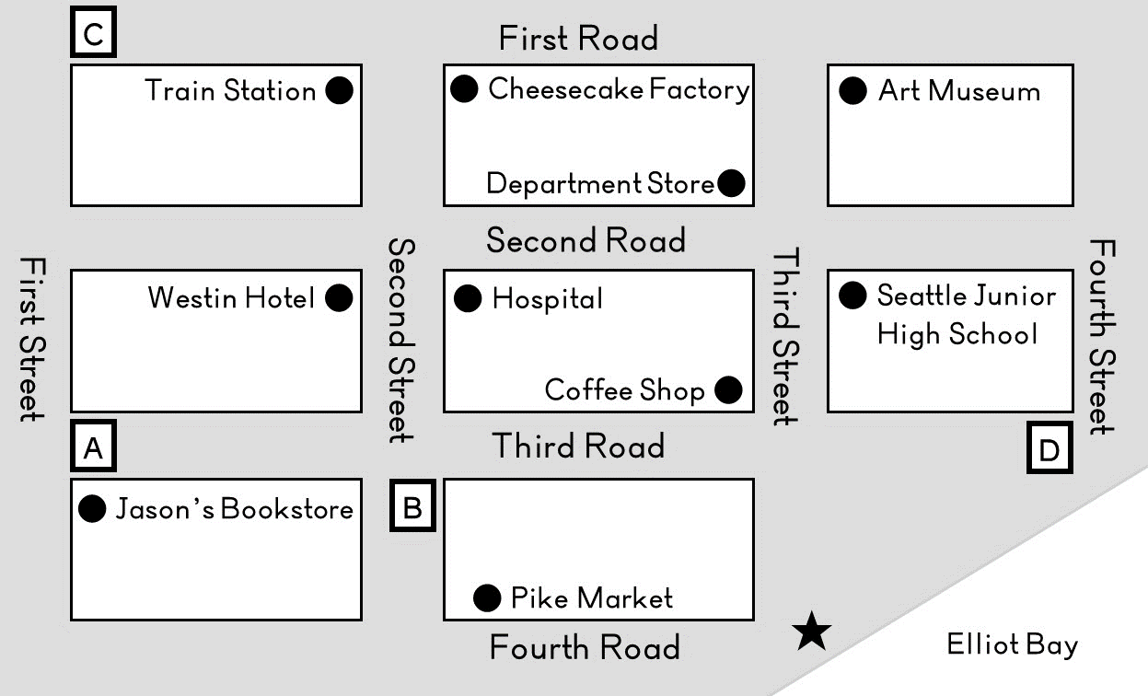
It takes me
5 minutes to walk one block.
factory工廠 bay海峽
- Wally is going to have a dinner with Wendy at the Cheesecake Factory tonight.
Before dinner, he will buy some roses and a book for her.
17:00 Leave school.
17:15 Buy flowers at Pike Market
17:30 Buy a book at Jason’s Bookstore
17:45 Have dinner at Cheesecake Factory

Which way will Wally take after school?
① Third Street Fourth Road First Street First Road
② Second Road Second Street Fourth Road Third Street
③ Second Road Second Street Fourth Road First Street
④ Third Street Fourth Road Second Street Second Road

- On Wally’s way to the restaurant, he meets a lady.
Lady: | Excuse me. How can I get to the Art Museum?
Wally: | Go straight for two blocks. Turn left. Walk for two blocks. It is on your right.
Where are Wally and the lady now?
① | A | ② | B | ③ | C | ④ | D

- Wally and Wendy are taking a walk by the Elliot Bay after dinner.
Wendy has to be at the train station by nine forty tonight.
When should Wendy start off from the Elliot Bay to the train station?
① 9:10 a.m. ② 9:15 p.m. ③ 9:30 p.m. ④ 9:25 a.m.

